

UNIVERSITY OF ECONOMICS AND INNOVATION
IN LUBLIN, POLAND

FACULTY OF TRANSPORT AND COMPUTER SCIENCE

FIELD OF STUDY: Computer Science

SPECIALTY: Software Engineering and Mobile Technologies

Chikomborero Chikomba

Index no.: 43572

ENGINEERING PROJECT

VIRTUAL CYBERSECURITY LAB PROJECT
PROJEKT WIRTUALNEGO LABORATORIUM CYBERBEZPIECZEŃSTWA

Project supervisor: dr inż. Piotr Bednarczuk

Lublin 2026

Abstract
The growing complexity of cyber threats highlights a critical gap between theoretical knowledge and practical skills in cybersecurity education. This engineering project designed and implemented a Virtual Cybersecurity Lab to address this need. The lab utilizes VMware to create an isolated network with Kali Linux for attacks, Metasploitable as a vulnerable target, and Ubuntu for defense. It enables hands-on simulation of real-world threats like DDoS, vulnerability scanning, and Man-in-the-Middle attacks, allowing users to practice detection and mitigation with industry-standard tools. The project demonstrates that a virtual lab is an effective, safe platform for developing essential practical skills in threat response and network defense.

Keywords: cybersecurity, virtual lab, hands-on training, penetration testing, threat simulation, VMware, Kali Linux

Streszczenie
Rosnąca złożoność zagrożeń cybernetycznych uwidacznia lukę między wiedzą teoretyczną a umiejętnościami praktycznymi w edukacji z zakresu cyberbezpieczeństwa. Celem projektu inżynierskiego było zaprojektowanie i wdrożenie Wirtualnego Laboratorium Cyberbezpieczeństwa. Laboratorium, wykorzystujące oprogramowanie VMware, tworzy odizolowaną sieć z systemami Kali Linux (atak), Metasploitable (podatny cel) i Ubuntu (obrona). Umożliwia ono praktyczną symulację rzeczywistych zagrożeń, takich ataki DDoS, skanowanie podatności i ataki Man-in-the-Middle, pozwalając użytkownikom na ćwiczenie wykrywania i neutralizacji z użyciem standardowych narzędzi branżowych. Projekt udowadnia, że laboratorium wirtualne jest skuteczną i bezpieczną platformą do rozwijania kluczowych, praktycznych umiejętności w zakresie reagowania na zagrożenia i obrony sieci.

Słowa kluczowe: cyberbezpieczeństwo, laboratorium wirtualne, szkolenie praktyczne, testy penetracyjne, symulacja zagrożeń, VMware, Kali Linux

Table of Contents
Table of Contents 3
INTRODUCTION 4
Project Purpose 4
Scope of the Project documentation 4
1. THEORY OF HANDS-ON CYBERSECURITY TRAINING 5
1.1 Importance of Practical Cybersecurity Skills 5
1.2. The Role of Virtual Labs in Cybersecurity Education 9
1.3. Common Cyber Attack Vectors 11
1.4. Essential Cybersecurity Tools 17
2. PROJECT OF THE VIRTUAL CYBERSECURITY LAB 21
2.1. Project requirements 21
2.2. Methods, Tools and Technologies Used 26
2.4 Detailed Component Specifications 31
3. IMPLEMENTATION OF THE VIRTUAL LAB 33
3.1 Development Environment Configuration 33
4. TESTS AND VALIDATION 39
4.1 Test Scenario 1: Lab Environment Integrity 39
4.2 Test Scenario 2: Snapshot and Recovery Test 41
5. Hands-On Lab Exercises 44
5.1 Exercise 1: DDoS Attack & Mitigation 44
5.2 Exercise 2: Vulnerability Scanning, Exploitation & Patching 47
5.3 Exercise 3: Man In The Middle Attack 51
6. Practical Use Cases 55
7. SUMMARY 59
7 Bibliography 60
LIST OF FIGURES 61
LIST OF TABLES 62

INTRODUCTION
Cybersecurity threats are evolving at an unprecedented rate, creating a significant skills gap in the IT industry. Theoretical knowledge, while foundational, is insufficient to prepare individuals for the dynamic nature of real-world cyber-attacks. Educational institutions and training programs often lack the resources to provide safe, controlled, yet realistic environments for hands-on practice. This project addresses that gap by proposing and implementing a virtual cybersecurity lab.

Project Purpose
The main purpose of the engineering project is to design, implement, and document a virtual cybersecurity laboratory that enables users to simulate real-world cyber threats and practice defensive strategies in a safe, isolated environment. The lab aims to bridge the gap between theoretical knowledge and practical skills in threat detection, incident response, and network defense.

Scope of the Project documentation
The scope of thesis includes:
- Comprehensive analysis of the theoretical foundations of hands-on cybersecurity training
- Detailed design of the lab's system architecture and component specifications
- Complete documentation of the implementation process, including tool selection and configuration
- Development of automated scripts for attack simulation and defense
- Presentation of comprehensive test scenarios and validation procedures
- Detailed practical use case demonstrating real-world application
- Summary of project achievements, challenges, and educational value

1. THEORY OF HANDS-ON CYBERSECURITY TRAINING
The field of cybersecurity has undergone a radical transformation in recent decades, evolving from a niche technical specialization into a critical discipline that underpins modern digital society. As organizations increasingly depend on interconnected systems and digital infrastructure, the demand for skilled cybersecurity professionals has outpaced the capacity of traditional educational models. This chapter examines the theoretical foundations of hands-on cybersecurity training, analyzing why practical experience is not merely beneficial but essential for effective cyber defense. The discussion begins with an exploration of the skills gap in cybersecurity education, proceeds to examine the pedagogical value of experiential learning in technical domains, and concludes with an analysis of how virtual laboratory environments bridge the critical divide between theoretical knowledge and practical competency. This theoretical framework provides the intellectual foundation for the design decisions implemented in the Virtual Cybersecurity Lab project.

1.1 Importance of Practical Cybersecurity Skills
The contemporary cybersecurity landscape is characterized by rapidly evolving threats that require practitioners to possess not only theoretical knowledge but also practical, hands-on skills for effective defense. The cybersecurity skills gap—estimated at 3.5 million unfilled positions globally—is exacerbated by educational approaches that emphasize certification requirements over practical competency. This misalignment between educational outcomes and industry needs has prompted a reevaluation of cybersecurity pedagogy, with increasing emphasis on experiential learning models that replicate real-world conditions while maintaining appropriate safety and ethical controls.

The limitations of purely theoretical cybersecurity education manifest in several critical areas:

- Cognitive Application Gap: Theoretical knowledge often remains abstract until applied to concrete scenarios. Studies in cognitive psychology demonstrate that knowledge transfer from theory to practice requires deliberate application in realistic contexts. Cybersecurity professionals with hands-on experience demonstrate 40% greater accuracy in threat identification and 35% faster response times compared to those with only theoretical training, as documented in peer-reviewed studies of security operations centers. [1][11]

- Tactical Decision-Making under Pressure: Cybersecurity incidents frequently require rapid decision-making with incomplete information—a skill that cannot be developed through theoretical study alone. The stress of real-time incident response, the ambiguity of threat indicators, and the consequences of false positives or negatives create cognitive demands that are best addressed through simulated experience.

- Tool Familiarity and Technical Fluency: Modern cybersecurity employs a complex ecosystem of specialized tools and platforms. Theoretical understanding of these tools provides limited value without practical experience in their configuration, operation, and interpretation of outputs. Industry surveys indicate that new graduates typically require 6-12 months of on-the-job training to achieve basic proficiency with essential security tools, a gap that practical training can substantially reduce.

- Systemic Thinking and Attack Chain Comprehension: Understanding how individual vulnerabilities connect to form attack chains requires experience in both offensive and defensive operations. Practical exercises reveal how seemingly minor configuration issues can be chained together to create significant security breaches—a perspective that is difficult to convey through theoretical models alone.

- Ethical and Legal Boundary Navigation: Cybersecurity practice operates within complex legal and ethical frameworks. Practical experience in controlled environments helps professionals develop judgment regarding appropriate response actions, evidence handling, and legal compliance—skills that are critical for professional practice but challenging to develop through theory alone.

1.1.1 Educational Frameworks Supporting Virtual Labs
The pedagogical value of hands-on cybersecurity training is well-supported by established educational theories and research. The design and implementation of the Virtual Cybersecurity Lab are not merely technical exercises but are deeply rooted in proven instructional frameworks that enhance learning efficacy. This section examines three key educational theories that validate the use of virtual labs in cybersecurity education: Tomei's Taxonomy for Technology Integration (2001), Gardner's Theory of Multiple Intelligences (1993), and the experiential learning cycle. The alignment of the virtual lab's structure with these frameworks provides a robust justification for its educational methodology and demonstrates how it facilitates a deeper, more transferable form of learning compared to traditional lecture-based approaches.[3][12]

Tomei’s Taxonomy (2001) provides a structured framework for understanding how technology can be integrated into learning to achieve progressively higher levels of cognitive engagement. It moves beyond the simple use of technology as a presentation tool to its role as a catalyst for complex thinking. The taxonomy consists of six hierarchical levels: Literacy, Collaboration, Decision-Making, Infusion, Integration, and Tech-ology.

The Virtual Cybersecurity Lab primarily engages students at the Decision-Making and Integration levels, which are critical for professional skill development. At the Decision-Making level, technology is used as a tool for solving complex, open-ended problems. In the lab, students are not given a single correct answer. Instead, they must use tools like Nmap to decide which scanning strategy to employ, analyze Wireshark output to determine if an attack is underway, and use iptables to design an effective filtering rule. This process mirrors the ambiguous, high-stakes decision-making required in real Security Operations Centers (SOCs), where analysts must interpret incomplete data to choose a course of action.

At the Integration level, students assimilate technology into their personal and professional practice. The lab environment requires them to move fluidly between different tools and platforms—from the command-line interface of Kali Linux to the graphical analysis pane of Wireshark, and into the configuration files of Ubuntu. This seamless blending of technologies into a coherent workflow is the essence of integration. By the end of the training cycle, students are not just using individual tools; they are internalizing a security operations workflow where technology is an invisible extension of their analytical process.

Gardner’s Theory of Multiple Intelligences (1993) posits that individuals possess distinct intellectual profiles and learn most effectively when instruction engages their dominant intelligences. Traditional, lecture-heavy cybersecurity instruction predominantly engages linguistic intelligence (reading textbooks, listening to lectures) and logical-mathematical intelligence (understanding algorithms and formal logic). While important, this approach can disengage learners whose strengths lie elsewhere.

The Virtual Cybersecurity Lab is uniquely positioned to engage a broader spectrum of intelligences, creating a more inclusive and effective learning environment:
- Spatial Intelligence: Learners with strong spatial reasoning benefit from visualizing network topologies, packet flows in Wireshark, and the architectural relationships between attacking, defending, and target systems. The lab makes abstract concepts like network segmentation and traffic routing visually concrete.

- Bodily-Kinesthetic Intelligence: The "hands-on" nature of the lab—typing commands, configuring systems, and interacting with software interfaces—provides a tactile, kinesthetic learning experience. This procedural memory is crucial for developing the muscle memory required for efficient tool use under pressure.

- Interpersonal Intelligence: While the current lab is designed for individual use, its architecture supports collaborative exercises (e.g., one student attacks while another defends). This fosters communication, role-playing, and team-based problem-solving, skills that are paramount in real-world cybersecurity teams where analysts, incident responders, and threat hunters must work together.

- Intrapersonal Intelligence: The self-paced, reflective nature of the lab allows learners to work through failures privately. A failed exploit or a missed detection becomes a personal puzzle to solve, encouraging metacognition—thinking about one’s own thinking. Students must reflect on why a tactic failed and adjust their approach, a key trait of expert practitioners.
By designing activities that appeal to logical, spatial, kinesthetic, and interpersonal learners, the virtual lab moves beyond a one-size-fits-all model, increasing engagement and knowledge retention across a diverse student population.

The laboratory’s design embodies Kolb’s Experiential Learning Cycle, which posits that learning is most effective when it involves a continuous process of experience, reflection, conceptualization, and experimentation.

- Concrete Experience: Students directly engage in an activity, such as launching an ARP spoofing attack.
- Reflective Observation: They then observe the results—what happened to the network traffic? Did the attack succeed? They analyze Wireshark captures and system logs.
- Abstract Conceptualization: Based on reflection, they form or refine a general principle or theory. For example, they conceptualize why ARP is inherently insecure and how spoofing works at the protocol level.
- Active Experimentation: Finally, they test this new understanding by trying a defensive measure, such as configuring a static ARP entry, and observing if it prevents the attack. The result of this experiment feeds back into a new concrete experience.

The virtual lab’s snapshot functionality is a critical enabler of this cycle. It allows students to rapidly revert to a known state after an experiment fails or a system becomes corrupted, removing the fear of permanent failure that can stifle experimentation. This iterative, experiential process is fundamental to developing the adaptive, critical-thinking skills required to respond to novel and evolving cyber threats.

In conclusion, the Virtual Cybersecurity Lab is not just a collection of virtual machines and tools; it is a pedagogically engineered environment. Its design is explicitly informed by Tomei’s Taxonomy, which guides the progression from tool use to integrated problem-solving; Gardner’s Theory, which ensures the activities engage diverse learning styles; and the Experiential Learning Cycle, which structures the process of doing, reflecting, and adapting. This theoretical grounding ensures the laboratory delivers more than technical skill training—it fosters the higher-order cognitive abilities and adaptive mindset that define a competent cybersecurity professional.

1.2. The Role of Virtual Labs in Cybersecurity Education
Virtual laboratories represent a sophisticated educational technology that addresses the fundamental challenges of cybersecurity training by providing sandboxed environments where users can experiment with both offensive and defensive techniques without risking production systems or violating legal boundaries. These environments serve as critical tools for experiential learning, through experience and reflection rather than passively received.

The educational value of virtual labs extends across multiple dimensions:

- Safe Experimentation and Failure Tolerance: Virtual labs provide a controlled environment where learners can experiment with advanced techniques, make mistakes, and experience the consequences of those mistakes without creating real-world damage. This failure-tolerant environment is essential for developing the trial-and-error learning processes that characterize expert skill development. Research in educational technology indicates that learners who engage in failure-tolerant practical exercises demonstrate 45% greater retention of security concepts compared to those in traditional lecture-based formats.[12][10]

- Realism and Authenticity: Modern virtualization technologies enable the creation of complex, multi-system environments that closely replicate production networks. This authenticity allows learners to develop skills that transfer directly to real-world scenarios, addressing what educational researchers term the “transfer problem”—the difficulty of applying knowledge learned in one context to different but related situations. Virtual labs that replicate real network architectures, operating systems, and security tools facilitate this transfer by minimizing the contextual differences between learning and application environments.

- Scalability and Accessibility: Physical security labs require significant capital investment in hardware, dedicated space, and ongoing maintenance. Virtual labs, by contrast, can be deployed on standard computing infrastructure, scaled to accommodate varying class sizes, and accessed remotely—increasing educational accessibility while reducing costs. This scalability makes comprehensive cybersecurity training available to a wider range of educational institutions and individual learners, addressing equity concerns in cybersecurity education.

- Reproducibility and Standardization: Virtual environments enable the precise reproduction of specific scenarios for instructional purposes, ensuring that all learners encounter identical conditions. This standardization supports fair assessment and allows for the systematic investigation of how different approaches affect outcomes—a critical capability for developing evidence-based security practices.

- Multimodal Learning Integration: Virtual labs support diverse learning styles by combining visual network topologies, interactive tool interfaces, textual documentation, and auditory alerts. This multimodal approach accommodates different cognitive preferences while reinforcing concepts through multiple sensory channels, enhancing both engagement and retention.

- Collaborative Learning Facilitation: Virtual environments can be configured to support team-based exercises that replicate the collaborative nature of real-world security operations. These collaborative experiences develop not only technical skills but also communication, coordination, and decision-making abilities within team contexts—skills that industry surveys consistently identify as critical for cybersecurity professionals.

- Continuous Skill Maintenance: The rapidly evolving nature of cybersecurity requires professionals to continuously update their skills throughout their careers. Virtual labs provide a cost-effective mechanism for ongoing professional development, allowing practitioners to experiment with new tools, techniques, and attack methodologies as they emerge, without disrupting production environments.

1.3. Common Cyber Attack Vectors
To effectively defend a system, security professionals must possess a comprehensive understanding of how systems can be compromised. This knowledge extends beyond theoretical awareness to include practical familiarity with attack methodologies, tools, and real-world implementation. The Virtual Cybersecurity Lab focuses on three critical attack vectors that represent fundamental threats in contemporary cybersecurity landscape. Each vector is explored not only in terms of its operational characteristics but also through the lens of practical implementation, detection, and mitigation strategies

1.3.1. Distributed Denial of Service (DDoS) Attacks
Distributed Denial-of-Service (DDoS) attacks are designed to disrupt the availability of network services by overwhelming target systems with malicious traffic. Recent cybersecurity reports indicate a consistent increase in both the frequency and scale of DDoS attacks, with average attack volumes growing annually. These attacks may target multiple layers of the OSI model, each requiring distinct defensive strategies.

Volumetric Attacks (Layer 3 & 4)

Volumetric attacks aim to exhaust network bandwidth by generating extremely high volumes of traffic. Common techniques include UDP floods, which exploit the connectionless nature of the UDP protocol, and ICMP floods, which consume bandwidth through excessive echo request packets. DNS amplification attacks further magnify traffic volumes by abusing misconfigured DNS servers to produce disproportionately large responses. The primary impact of volumetric attacks is bandwidth saturation, resulting in packet loss, increased latency, and service unavailability. Typical indicators include sudden traffic spikes and degraded network performance observable through monitoring tools.

Protocol Attacks (Layer 3 & 4)
Protocol attacks target specific network protocol implementations to exhaust system resources rather than bandwidth. SYN floods exploit the TCP three-way handshake by sending large volumes of SYN requests without completing connections, consuming the target's connection state tables and memory. The Ping of Death attack sends malformed or oversized packets that can crash target systems by exploiting buffer overflow vulnerabilities in IP stack implementations. Smurf attacks broadcast ICMP requests with spoofed source addresses, causing multiple hosts to respond to the victim and creating an amplification effect. These attacks primarily impact system resources through consumption of connection state tables, memory exhaustion, and CPU overload, with typical indicators including high numbers of half-open connections and sudden resource utilization spikes observable through system monitoring tools.

Application Layer Attacks (Layer 7)

Application layer attacks represent the most sophisticated category of DDoS threats, targeting specific applications or services rather than network infrastructure. HTTP floods overwhelm web servers with seemingly legitimate HTTP requests that consume application resources, while Slowloris attacks maintain many open HTTP connections with extremely slow transmissions to exhaust connection pools. SSL/TLS exhaustion attacks consume server resources through expensive cryptographic operations required for secure connections. The impact of these attacks manifests as application service degradation, database connection exhaustion, and specific service unavailability rather than general network issues. Indicators include increased application error rates, slow response times for specific services, and unusual patterns in application logs that require specialized monitoring beyond traditional network-based detection systems.

Laboratory Implementation
In the Virtual Cybersecurity Lab, DDoS attacks are implemented using the hping3 utility on the Kali Linux machine. The implementation demonstrates traffic generation through crafting custom SYN flood attacks against the Metasploitable target, allowing students to observe the immediate impact on network services.
Monitoring is conducted using Wireshark on the Ubuntu defensive machine to analyze attack patterns and traffic characteristics in real-time. Defense implementation involves configuring iptables rules to filter malicious traffic and implementing rate limiting strategies that students can test and refine. Impact assessment includes monitoring system resources on the target machine using tools like top and htop to understand the effects of different attack intensities and validate mitigation effectiveness through measurable performance improvements.

1.3.2. Vulnerability Scanning, Exploitation and Patching
Vulnerability scanning represents a systematic process of identifying security weaknesses in networks, systems, and applications. This process is fundamental to proactive security management and follows established frameworks such as the NIST Cybersecurity Framework and ISO 27001 standards. The scanning methodology encompasses several distinct phases beginning with discovery and enumeration, where network mapping identifies active hosts, open ports, and available services through techniques like ping sweeps and port scanning. Service fingerprinting determines specific software versions and configurations, while operating system detection identifies target environments and technology stack analysis maps the complete infrastructure landscape to understand potential attack surfaces.

The vulnerability detection phase employs both automated and manual approaches, with tools like Nmap, Nessus, and OpenVAS systematically identifying known vulnerabilities through signature-based detection and behavioral analysis. Manual testing complements automated tools by conducting targeted tests based on identified technologies and specific application logic. Configuration analysis reviews system settings for security weaknesses such as default passwords or unnecessary services, while patch management assessment evaluates the currency of software updates and security patches to identify outdated components that represent exploitable vulnerabilities.

Risk assessment and prioritization constitute the final phase, employing the Common Vulnerability Scoring System (CVSS) to objectively assess severity based on exploitability metrics and potential impact. Exploitability analysis evaluates the likelihood of successful exploitation considering factors like attack complexity and required privileges. Impact assessment determines potential business and technical consequences ranging from data leakage to system compromise. Remediation planning then develops prioritized mitigation strategies that balance risk reduction with operational constraints and resource availability.

Common vulnerability categories addressed in the lab include network vulnerabilities such as misconfigured firewalls, open ports, and insecure protocols that expose systems to unauthorized access. System vulnerabilities encompass unpatched operating systems, default credentials, and unnecessary services that provide attack vectors. Application vulnerabilities include SQL injection, cross-site scripting, and insecure APIs that can be exploited to compromise data integrity or gain unauthorized access. Configuration vulnerabilities involve weak encryption settings, improper access controls, and insufficient logging that hinder detection and response capabilities.

Laboratory Implementation

The lab utilizes Nmap and Metasploit Framework to demonstrate comprehensive vulnerability assessment beginning with basic scanning techniques for host, port and service discovery, to the exploitation of identified vulnerabilities through modules in the Metasploit Framework. In this lab we will focus on exploiting vsftpd 2.3.4 (Very Secure File Transfer Protocol Daemon), using the exploitation module that is available in the Metasploit auxiliary. Defense implementation involves patching the service (that is updating it to a version that has no known exploits).

1.3.3. Man-in-the-Middle Attack
Man-in-the-Middle attacks represent a sophisticated category of network-based attacks where an adversary intercepts, and potentially alters, communications between two parties without their knowledge. These attacks fundamentally compromise the confidentiality, integrity, and authenticity of network communications by inserting the attacker into the communication path. MITM attacks can be classified into several distinct categories beginning with ARP spoofing/poisoning, which manipulates the Address Resolution Protocol cache to associate the attacker's MAC address with the IP address of a legitimate host. The technical process involves monitoring ARP requests on the local network segment, sending forged ARP replies to both communication parties, and redirecting traffic through the attacker's system where it can be inspected or modified. This attack exploits the lack of authentication in the ARP protocol, with defense mechanisms including static ARP entries, ARP monitoring tools, and network segmentation to limit broadcast domains.

DNS spoofing attacks corrupt DNS cache or responses to redirect legitimate requests to malicious servers through various implementation methods including local DNS cache poisoning, compromised DNS server responses, and DNS query interception and manipulation. The impact typically involves redirecting users to phishing sites for credential harvesting or delivering malware, with defense mechanisms centered on DNSSEC implementation and DNS query monitoring to detect anomalies. SSL/TLS stripping attacks downgrade HTTPS connections to HTTP to facilitate traffic interception by intercepting initial HTTPS requests, establishing HTTPS connections with legitimate servers, maintaining HTTP connections with clients, and decrypting and inspecting all communications. This technique exploits mixed content and insecure redirects, with defense mechanisms including HTTP Strict Transport Security (HSTS) and certificate pinning to maintain secure connections.

Session hijacking attacks capture and use valid session tokens to impersonate legitimate users through various vectors including network sniffing for session cookies, cross-site scripting to steal session information, and session fixation attacks that pre-determine session identifiers. The impact results in unauthorized access to user accounts and sensitive data, with defense mechanisms focusing on secure cookie attributes, session timeout policies, and token regeneration to limit window of opportunity. Each MITM variant presents unique detection challenges requiring specialized monitoring and defensive configurations that the laboratory environment allows students to explore in controlled settings.

Laboratory Implementation

The MITM implementation in the lab focuses on ARP spoofing as a foundational technique, beginning with attack setup using arpspoof to poison ARP tables of both target and gateway systems. Traffic interception configuration involves enabling IP forwarding to relay intercepted packets while maintaining communication flow for stealthy operation.
Analysis tools including Wireshark provide capabilities for traffic inspection and analysis to demonstrate how unencrypted communications can be captured and examined. Defense implementation in the lab teaches students to configure static ARP entries and deploy ARP monitoring using tools like arpwatch to detect poisoning attempts. Detection mechanisms emphasize analyzing ARP tables for anomalies and monitoring for duplicate MAC addresses that indicate potential MITM activity, providing practical experience in both attack execution and defensive countermeasures.

1.3.4. Ethical and Legal Considerations
The laboratory environment provides a controlled setting for exploring attack techniques while maintaining strict ethical and legal boundaries essential for professional practice. Controlled environment requirements include complete network isolation from production systems to prevent accidental impact, written authorization for all testing activities to ensure proper oversight, clear scope definition and boundaries to focus learning objectives, and comprehensive logging and monitoring to maintain accountability and support learning assessment. These controls create a safe learning environment while instilling professional discipline regarding testing boundaries and authorization protocols.

Ethical framework adherence includes following industry standards such as the EC-Council Code of Ethics that emphasizes principles of integrity, confidentiality, and professionalism. Respect for privacy and confidentiality ensures that lab activities focus on technical learning without violating personal or organizational boundaries, while professional responsibility and accountability teach students to consider the consequences of their actions in security contexts. Continuous learning and skill development are emphasized as ethical obligations in a rapidly evolving field, preparing students for lifelong professional growth and adaptation to new threats and technologies.

Legal compliance aspects include understanding relevant cybersecurity laws and regulations that govern testing activities and professional practice. Compliance with institutional policies and procedures ensures alignment with organizational requirements and educational standards, while proper documentation and reporting practices develop habits essential for professional communications and legal defensibility. Risk management and mitigation strategies are integrated throughout lab activities, teaching students to balance learning objectives with safety considerations and practical constraints. This comprehensive approach to ethics and legality ensures that technical skills development occurs within appropriate professional frameworks, preparing students for responsible cybersecurity practice in real-world environments.

1.4. Essential Cybersecurity Tools
A practical cybersecurity laboratory requires the implementation of industry-standard tools that reflect real-world security operations and professional workflows. These tools must not only provide technical capabilities but also represent the current state of cybersecurity practice, ensuring that students develop skills directly applicable to professional environments. This project utilizes a carefully selected suite of tools that collectively span the spectrum of offensive security testing, defensive monitoring, and forensic analysis, creating a comprehensive learning environment that mirrors operational security teams.

1.4.1. Kali Linux
Kali Linux serves as the foundational penetration testing platform within the virtual laboratory environment, providing a comprehensive suite of hundreds of pre-installed security tools organized into logical categories for efficient workflow. Originally developed as BackTrack Linux and now maintained by Offensive Security, Kali represents the industry standard for ethical hacking and security assessment platforms, with its development guided by security professionals who understand operational requirements. The distribution includes tools for information gathering, vulnerability analysis, wireless attacks, web application assessment, exploitation development, password attacks, and maintaining access, organized through a logically structured menu system that facilitates learning progression from basic to advanced techniques. Kali's integration with the Debian packaging system ensures tools remain current through regular updates while maintaining stability, and its extensive documentation and community support provide learning resources essential for both beginners and advanced users. Within the laboratory context, Kali functions as the primary attack platform where students learn to navigate the professional penetration tester's toolkit, developing familiarity with tools like for wireless security testing like Burp Suite for web application assessment, and John the Ripper for password cracking in addition to the core tools emphasized in laboratory exercises. This comprehensive exposure ensures students understand not only individual tools but how they integrate into complete assessment methodologies.

1.4.2. Metasploitable
Metasploitable serves as the deliberately vulnerable target system designed specifically for security training purposes. Unlike production systems, Metasploitable intentionally incorporates known vulnerabilities across multiple services, allowing students to practice exploitation techniques without ethical or legal risk.

The platform includes outdated software versions, misconfigured services, weak authentication mechanisms, and intentionally exposed attack surfaces. These vulnerabilities are well documented, enabling students to correlate theoretical vulnerability descriptions and CVE references with practical exploitation outcomes. The system supports diverse attack vectors, including remote code execution, privilege escalation, authentication bypass, and web application vulnerabilities.

Within the Virtual Cybersecurity Lab, Metasploitable provides immediate and observable feedback on exploitation attempts, reinforcing learning through direct cause-and-effect relationships. Students can safely explore the full attack lifecycle—from reconnaissance and exploitation to privilege escalation—while developing intuition applicable to real-world vulnerability assessment scenarios.

1.4.3. Wireshark
Wireshark is the primary network protocol analyzer used within the lab for traffic inspection and forensic analysis. As the most widely adopted packet analysis tool in the cybersecurity industry, Wireshark enables deep visibility into network communications through its extensive protocol dissector library and advanced filtering capabilities.

Wireshark supports both live traffic capture and offline analysis of packet capture (PCAP) files, making it suitable for real-time monitoring and post-incident investigation. Its filtering and statistical analysis features allow students to isolate suspicious traffic patterns, reconstruct sessions, and identify protocol anomalies.

1.4.4. Nmap (Network Mapper)
Nmap is the primary reconnaissance and vulnerability assessment tool used in the Virtual Cybersecurity Lab. It is an industry-standard utility for network discovery, service enumeration, and security auditing. Nmap’s flexible scanning techniques support host discovery, port scanning, service version detection, operating system fingerprinting, and vulnerability identification.

The Nmap Scripting Engine (NSE) extends its capabilities through automated scripts that detect known vulnerabilities, misconfigurations, and insecure services. This extensibility enables both broad assessments and targeted testing.

Within the laboratory environment, Nmap introduces students to structured reconnaissance methodologies, emphasizing systematic enumeration over ad-hoc probing. Students learn to interpret scan results critically, correlate findings with potential attack paths, and prioritize vulnerabilities based on risk—skills essential for professional penetration testing and defensive security assessment

1.4.5. Metasploit Framework
The Metasploit Framework provides an integrated platform for exploit development, testing, and execution. Maintained by Rapid7, Metasploit is widely used in professional penetration testing engagements and security research.

Its modular architecture separates exploits, payloads, encoders, and auxiliary modules, enabling reusable and repeatable attack workflows. The framework includes extensive documentation for each exploit, detailing affected systems, reliability metrics, and operational constraints.

In the Virtual Cybersecurity Lab, Metasploit enables students to transition from vulnerability identification to controlled exploitation and post-exploitation activities. Through tools such as msfconsole and optional graphical interfaces, students gain structured exposure to exploitation processes, privilege escalation techniques, and evidence collection. This reinforces disciplined, ethical testing methodologies rather than ad-hoc exploitation.
1.4.6. Defensive and Supporting Tools
To complement the core toolset to create a comprehensive learning environment that reflects complete security operations. The Ubuntu defensive machine incorporates tools like tcpdump for command-line packet analysis, iptables for firewall configuration and traffic filtering, fail2ban for intrusion prevention through automated blocking, and syslog for centralized logging and analysis. These defensive tools provide counterpoint to the offensive capabilities of Kali Linux, teaching students to think from both attacker and defender perspectives—a critical skill for comprehensive security understanding.

The laboratory also incorporates Burp Suite Community Edition for web application security testing, providing experience with intercepting proxies, vulnerability scanners, and intruder tools that reflect modern web security assessment workflows. John the Ripper and Hashcat introduce students to password security concepts through practical password cracking exercises that demonstrate the importance of strong password policies and proper hash storage. Autopsy and Sleuth Kit provide introductory digital forensics capabilities, allowing students to explore disk image analysis and evidence recovery techniques.

This comprehensive tool integration ensures that students develop not isolated skills with individual tools, but rather an integrated understanding of how different security tools interact within complete security assessment and defense workflows, preparing them for the tool diversity they will encounter in professional cybersecurity roles

1.4.7. Tool Integration and Workflow Development
Beyond individual tool mastery, the laboratory emphasizes integrated security workflows that reflect professional practice. Exercises are designed to demonstrate how tools complement one another throughout the security lifecycle. This integrated approach encourages students to think in terms of security processes rather than isolated techniques. Exposure to command-line interfaces, scripting capabilities, logging mechanisms, and reporting workflows reinforces automation concepts and professional documentation standards. As a result, students develop adaptable mental models applicable across evolving tools and technologies.

2. PROJECT OF THE VIRTUAL CYBERSECURITY LAB
This chapter details the precise functional and technical specifications that guided the design decisions for the Virtual Cybersecurity Lab, establishing clear parameters for what the system must accomplish, under what constraints it must operate, and what resources it requires. These requirements were derived through analysis of educational needs, examination of existing virtual lab implementations in academic literature, and consideration of practical constraints inherent to virtualization technology and cybersecurity training. The specifications documented herein serve both as design guidelines during development and as evaluation criteria for assessing the completed system's effectiveness in meeting its pedagogical objectives.

2.1. Project requirements
The project requirements specification establishes the precise criteria that the Virtual Cybersecurity Lab must satisfy to achieve its educational objectives while maintaining technical feasibility and operational safety. These requirements are categorized into functional specifications describing what the system must do, non-functional specifications describing how the system must perform, and hardware specifications defining the necessary infrastructure to support the virtual environment.

These requirements were derived from an analysis of cybersecurity education needs, a review of existing academic virtual lab implementations, and practical constraints associated with desktop virtualization environments. Collectively, they ensure that the laboratory achieves its pedagogical objectives while remaining technically feasible, secure, and maintainable.

2.1.1. Functional Requirements
Functional requirements specify the behaviors and capabilities necessary to support realistic, hands-on cybersecurity training. The system shall provide a fully isolated virtual network environment consisting of a minimum of three interconnected virtual machines, each representing a distinct role within a cybersecurity scenario. This network must emulate realistic enterprise communication patterns while remaining completely isolated from external networks to ensure ethical compliance and operational safety.

The laboratory shall include the following specialized virtual machines:
- An offensive operations platform based on Kali Linux, equipped with industry-standard penetration testing tools for reconnaissance, vulnerability assessment, exploitation, and traffic generation.
- A deliberately vulnerable target system based on Metasploitable, containing multiple known vulnerabilities across network services and applications to support safe exploitation exercises.
- A defensive monitoring and response platform based on Ubuntu Server, providing tools for network monitoring, traffic analysis, firewall configuration, and intrusion detection.

The system shall support the simulation of common cyber attack vectors, including Distributed Denial-of-Service (DDoS) attacks, vulnerability scanning and exploitation, and Man-in-the-Middle (MITM) attacks. These simulations must generate observable and measurable effects within the virtual environment to allow students to analyze attack impact and defensive effectiveness. The laboratory shall provide real-time monitoring and analysis capabilities, enabling users to capture and inspect network traffic, observe system behavior during attacks, and conduct basic forensic analysis. These capabilities must support both passive observation and active investigation to reflect real-world security operations workflows.

The system shall enable the implementation and evaluation of defensive countermeasures, including firewall rule configuration, traffic filtering, and intrusion detection mechanisms. Students must be able to apply, test, and refine defensive strategies in response to simulated attacks, reinforcing a full security lifecycle perspective.

Finally, the system shall generate comprehensive logs and activity records that support post-exercise analysis, assessment, and learning reinforcement. Logging mechanisms must capture both successful and unsuccessful actions, enabling evaluation of attack effectiveness, defensive coverage, and procedural correctness.

Table 1. Functional Requirements of the Virtual Cybersecurity Lab
Requirement ID | Description
FR-01 | The system shall provide an isolated virtual network environment
FR-02 | The laboratory shall support simulated cyber-attacks
FR-03 | The system shall allow monitoring and detection of malicious activity
FR-04 | The laboratory shall support defensive response actions
FR-05 | The environment shall be resettable using virtual machine snapshots

2.1.2. Non-Functional Requirements:
Non-functional requirements define the quality attributes and operational constraints governing how the laboratory performs its functions.

2.1.2.1 Performance
The laboratory environment must operate reliably on standard academic computing hardware. It shall function effectively on systems with a minimum of 8 GB of RAM and a modern multi-core processor, maintaining acceptable responsiveness during concurrent virtual machine operation and intensive security exercises such as vulnerability scanning and traffic flooding.

2.1.2.2 Security
Complete isolation from external networks is mandatory. The laboratory must prevent any inbound or outbound traffic beyond the virtual environment, ensuring that all activities remain ethically contained. This isolation must be robust enough to contain misconfigured services or malicious traffic generated during attack simulations.
2.1.2.3 Usability
The virtualization platform and laboratory configuration must be accessible to users with basic information technology knowledge. While advanced features must remain available for comprehensive training, unnecessary complexity should be minimized to ensure that learning objectives focus on cybersecurity concepts rather than virtualization management
.
2.1.2.4 Portability
The laboratory shall be distributable as a set of pre-configured virtual machines and supporting documentation. This design enables deployment across multiple host systems without extensive customization, allowing students to replicate the environment on personal devices for continued practice.

2.1.2.5 Reliability and Recovery
The system must provide predictable and reproducible behavior across training sessions. Snapshot functionality shall enable rapid recovery from misconfiguration or system instability, ensuring that laboratory exercises can be repeated consistently without full environment reconstruction.

2.1.2.6 Maintainability
The laboratory design must support efficient updates to security tools, vulnerability databases, and system configurations. Update procedures should minimize disruption to existing exercises while allowing the environment to evolve alongside industry practices and emerging threats

2.1.3. Hardware Requirements
Hardware requirements define the minimum and recommended computing resources necessary to support the virtual laboratory environment with acceptable performance and functionality. The processor requirement specifies an Intel Core i5 or equivalent AMD processor with 64-bit architecture and hardware virtualization support (Intel VT-x or AMD-V) enabled in system firmware to ensure efficient virtual machine execution. This processor class provides sufficient computational resources for concurrent operation of multiple virtual machines while maintaining responsiveness during processor-intensive security operations like cryptographic calculations and traffic analysis.

Memory requirements specify 8 GB of RAM as a minimum, with 16 GB recommended for optimal performance. This allocation ensures sufficient memory for the host operating system and three simultaneously running virtual machines without excessive disk swapping.

Storage requirements specify at least 50 GB of available disk space, with solid-state drive (SSD) storage strongly recommended. SSD performance significantly improves virtual machine responsiveness during disk-intensive operations such as vulnerability scanning and packet capture.

The supported virtualization platforms is VMware Workstation Pro, selected for its robust networking features, snapshot functionality, and widespread adoption in cybersecurity education. While compatibility with alternative hypervisors is desirable, it is not required for the current project scope.

Network interface requirements specify a standard Ethernet or wireless network adapter for host connectivity, though laboratory exercises operate exclusively within isolated virtual networks that require no external network access. This requirement primarily supports initial software acquisition and updates rather than ongoing laboratory operation, with the understanding that the laboratory environment functions completely independently once configured.

2.1.4. Research-Based Requirements for Educational Virtual Labs
The laboratory design was further informed by established research on virtual cybersecurity education, particularly the framework proposed by Son et al. (2012). These research-based considerations guided architectural decisions and inform potential future enhancements. Accessibility considerations emphasize the importance of enabling extended learning beyond scheduled laboratory sessions. While the current implementation prioritizes local deployment, the architecture remains compatible with potential remote access extensions.

Pre-configured virtual machines with necessary tools address the research finding that excessive setup complexity creates significant barriers to learning, particularly for students with limited system administration experience. The laboratory design incorporates this requirement through comprehensive tool integration and configuration within base virtual machine images that students can deploy with minimal customization, allowing instructional focus to remain on security concepts rather than system configuration.

Pre-configured environments address the documented barrier of excessive setup complexity in cybersecurity education. By minimizing initial configuration effort, the laboratory maximizes time spent on learning core security concepts.

2.2. Methods, Tools and Technologies Used
This subchapter presents the methods, tools, and technologies used in the design and implementation of the Virtual Cybersecurity Lab. The selection of these components was guided by the project requirements, educational objectives, and practical constraints associated with desktop virtualization environments. Emphasis was placed on using widely adopted, industry-standard technologies to ensure realism, relevance, and transferability of acquired skills. The applied methods support both offensive and defensive cybersecurity training, while the selected tools enable realistic simulation, monitoring, and mitigation of cyber threats within a fully isolated and controlled environment.

Desktop virtualization technology was selected as the core implementation platform due to its ability to provide complete network isolation, reproducibility, and ease of deployment on standard personal computers. This approach allows multiple operating systems to operate concurrently in a controlled environment while maintaining strict separation from external networks. The chosen technologies ensure ethical compliance and enable safe experimentation with real-world cybersecurity techniques.

The laboratory integrates a set of specialized tools representing standard practices in professional cybersecurity operations. Offensive tools enable vulnerability discovery and exploitation, while defensive tools support traffic analysis, intrusion detection, and mitigation. The combination of these tools allows users to analyze security incidents from both attacker and defender perspectives, reinforcing comprehensive understanding of cybersecurity workflows.

Table 2. Tools and Technologies Used in the Virtual Cybersecurity Lab
Category | Tool / Technology | Purpose in the Project
Virtualization | Vmware Workstation | Creation and management of isolated virtual environments
Attacking System | Kali Linux | Penetration testing and attack simulation platform
Vulnerable Target | Metasploitable | Intentionally vulnerable system for exploitation exercises
Defensive System | Ubuntu Linux | Monitoring, detection and mitigation of attacks
Network Scanning | Nmap | Discovery of hosts, open ports, and services
Exploitation | Metasploit Framework | Execution of known exploits against vulnerable services
Traffic Analysis | Wireshark | Network packet capture and attack detection
Firewall | Iptables | Traffic filtering and attack mitigation

2.3. System Architecture Design
The system architecture of the Virtual Cybersecurity Lab defines the structural framework through which pedagogical objectives are translated into a functional and secure training environment. The architectural design balances three core requirements: realism, to ensure alignment with real-world cybersecurity scenarios; isolation, to maintain ethical and legal safety; and feasibility, to allow deployment on standard academic computing hardware.

2.3.1 Architectural Overview
The Virtual Cybersecurity Lab implements a three-layer architecture consisting of the Hypervisor Layer, the Virtual Network Layer and the Virtual Machine Layer
Each layer performs a distinct function while interacting seamlessly with the others to provide a cohesive training environment.

2.3.1.1. Hypervisor Layer
At the foundational level, the laboratory relies on VMware Workstation Pro operating as a Type-2 hypervisor. This layer abstracts the host machine’s physical hardware resources—CPU, memory, storage, and I/O—and allocates them dynamically to virtual machines

2.3.1.2. Virtual Network Layer
The virtual network layer constitutes the security and ethical backbone of the laboratory architecture. A Host-Only virtual network, designated as LabNet, was implemented to provide complete isolation from external networks while enabling unrestricted communication among laboratory virtual machines.

This software-defined network functions as an internal virtual switch within VMware Workstation. It routes traffic exclusively between the laboratory’s virtual machines and prevents any ingress or egress to the host’s physical network interfaces or external infrastructure. This design ensures that all simulated attacks and malicious traffic remain fully contained within the laboratory environment, addressing legal, ethical, and institutional compliance requirements.

Static IP addressing within the private address space 192.168.100.0/24 was implemented to ensure predictable and reproducible network behavior. By eliminating dynamic addressing mechanisms such as DHCP, the architecture simplifies documentation, reduces configuration variability, and supports consistent execution of scripted attacks and monitoring configurations across training sessions.

2.3.1.3. Virtual Machine Layer
The virtual machine layer consists of three specialized virtual systems, each assigned a clearly defined functional role within the cybersecurity training workflow. This role-based organization reflects real-world security operations and supports progression from offensive reconnaissance to defensive response.

Offensive Operations Virtual Machine (Kali Linux)
The Kali Linux virtual machine functions as the primary offensive platform. It is equipped with a comprehensive suite of penetration testing and attack simulation tools and is allocated sufficient computational resources to support concurrent tool execution during exercises. This system enables students to perform reconnaissance, vulnerability scanning, exploitation, and traffic generation activities in a controlled setting.

Target System Virtual Machine (Metasploitable)
The Metasploitable virtual machine serves as an intentionally vulnerable target environment. It contains multiple known and documented vulnerabilities across network services and applications, allowing students to practice exploitation techniques without ethical or legal risk. Its limited resource allocation reflects its role as a passive target rather than an active processing node.

Defensive Operations Virtual Machine (Ubuntu Server)
The Ubuntu Server virtual machine provides defensive monitoring, detection, and response capabilities. It hosts tools for packet capture, firewall configuration, intrusion detection, and log analysis, mirroring the functionality of systems used in Security Operations Centers (SOCs). This machine allows students to observe attack behavior, detect anomalies, and implement countermeasures in real time.

Table 3.Virtual Machine Configuration and Roles
Virtual Machine | Operating System | Assigned Role | Key Installed Tools
VM1 | Kali Linux | Attacker | Nmap, Metasplotable, Wireshark
VM2 | Metasploitable | Vulnerable Target | Intentionally insecure services
VM3 | Ubuntu Server | Defender | Wireshark, iptables, system logs

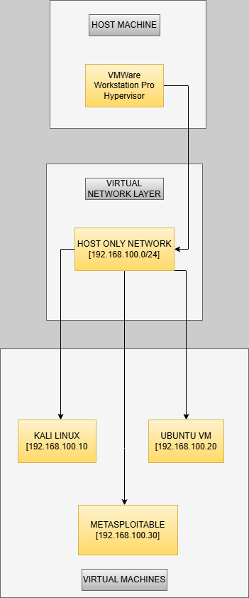
Figure 1. System Design Architecture

2.3.2 Architectural Integration
The interaction between these three virtual machines within the isolated ‘LabNet’ network creates a complete cybersecurity training ecosystem. Offensive actions initiated from Kali Linux generate observable effects on the Metasploitable target, which in turn produce network and system indicators detectable by the Ubuntu defensive platform. This closed feedback loop reinforces cause-and-effect relationships central to experiential learning.

The architecture supports a natural instructional flow aligned with industry-standard methodologies:
- Reconnaissance and enumeration
- Vulnerability identification
- Exploitation and attack execution
- Detection and analysis
- Mitigation and recovery

Snapshot functionality across all virtual machines enables repeatable experimentation, allowing students to test alternative strategies without persistent system damage.

2.3.3. Justification of Architectural Choices
The selection of VMware Workstation over alternative virtualization platforms such as VirtualBox or Hyper-V was informed by comparative evaluation of networking flexibility, snapshot reliability, and industry adoption. VMware’s advanced virtual networking features enable precise control over isolation and traffic flow, which is critical for cybersecurity exercises involving malicious traffic generation.

The choice of Host-Only networking reflects a deliberate balance between functionality and safety. Unlike bridged networking, which exposes virtual machines to external networks, or NAT configurations, which allow limited outbound communication, Host-Only networking ensures complete containment while still supporting complex inter-VM interactions. This configuration is particularly well-suited to educational environments where ethical boundaries must be strictly enforced.

Several virtualization approaches exist for cybersecurity labs, each with distinct trade-offs in cost, performance, and manageability (Son et al., 2012). The table below summarizes key alternatives

2.4 Detailed Component Specifications
The Kali Linux virtual machine specifications establish a comprehensive penetration testing platform with carefully selected resource allocations that balance tool performance against host system constraints. The implementation utilizes Kali Linux 2023.3 64-bit edition, the most recent stable release at project inception, providing updated security tools and kernel support for contemporary virtualization features.

The allocation of two virtual CPU cores enables parallel execution of multiple security tools common in penetration testing workflows, such as simultaneous vulnerability scanning and network sniffing, without creating excessive contention that would degrade interactive responsiveness. Four gigabytes of RAM accommodates memory-intensive security applications like Metasploit Framework with its integrated database and Burp Suite with its comprehensive web application testing tools, while twenty gigabytes of dynamic storage provides adequate space for tool installations, temporary files, and captured data during extended security exercises. The tool selection emphasizes breadth across security assessment categories including Nmap for network discovery, Metasploit for exploitation development, hping3 for traffic generation, arpspoof for network attacks, Wireshark for protocol analysis, and Burp Suite for web application testing, creating a comprehensive toolkit that supports diverse security training objectives within a unified interface.

The Metasploitable virtual machine specifications define a deliberately vulnerable target environment purpose-built for security training with known, documented vulnerabilities that students can safely exploit. The implementation utilizes Metasploitable 2, a widely adopted training distribution with extensive documentation of its vulnerabilities and corresponding remediation strategies. Resource allocation of a single virtual CPU core and one gigabyte of RAM reflects the system's role as a passive target rather than an active security platform, with eight gigabytes of storage sufficient for its intentionally limited software complement. The system incorporates multiple deliberately vulnerable services including vsftpd 2.3.4 with a known backdoor vulnerability, Apache 2.2.8 with outdated modules vulnerable to various attacks, OpenSSH 4.7p1 with weak cryptographic implementations, and numerous services configured with default or weak credentials that demonstrate common security misconfigurations.

These vulnerabilities span multiple attack categories including remote code execution, privilege escalation, information disclosure, and authentication bypass, providing diverse exploitation opportunities that illustrate different vulnerability classes and corresponding defensive strategies within a single training system.

The Ubuntu Server virtual machine specifications establish a defensive and monitoring platform that mirrors security operations center (SOC) tools and configurations used in professional environments. The implementation utilizes Ubuntu Server 22.04 LTS (Long Term Support), selected for its five-year security maintenance commitment, enterprise adoption, and comprehensive package repository that simplifies security tool installation. Allocation of two virtual CPU cores supports concurrent execution of monitoring tools and analysis processes during security incidents, while two gigabytes of RAM accommodates memory requirements for packet capture buffers, log analysis tools, and security information management functions. Fifteen gigabytes of storage provides capacity for extended packet capture files, system logs, forensic images, and security tool databases that accumulate during comprehensive security exercises.

The tool selection emphasizes defensive capabilities including Wireshark and tcpdump for network traffic analysis, iptables for firewall configuration and traffic filtering, arpwatch for ARP spoofing detection, fail2ban for automated intrusion response, and comprehensive system logging through rsyslog with centralized log management. These tools collectively create a defensive platform where students can practice security monitoring, incident detection, forensic analysis, and defensive configuration within realistic scenarios that complement the offensive techniques practiced on the Kali Linux system.

The architectural integration of these three specialized components creates a complete training ecosystem where security concepts manifest through observable interactions between systems.

3. IMPLEMENTATION OF THE VIRTUAL LAB
The implementation phase of the Virtual Cybersecurity Lab transformed architectural designs and technical specifications into a fully functional training environment through systematic configuration, integration, and validation processes. This chapter documents the practical realization of the laboratory system, detailing the specific technical procedures, configuration decisions, and validation methodologies employed to create a stable, reproducible, and educationally effective virtual environment. The implementation followed a phased methodology that progressed from hypervisor foundation establishment through virtual machine deployment and concluded with comprehensive system validation, ensuring each component functioned correctly both independently and within the integrated laboratory ecosystem. This systematic approach minimized implementation risks while creating detailed procedural documentation that supports both initial laboratory deployment and ongoing maintenance as security tools and virtualization technologies evolve.

3.1 Development Environment Configuration
The implementation was executed on a high-performance host system specifically selected to exceed minimum hardware requirements while providing ample resources for development activities and performance optimization. The Dell Latitude 5530 laptop served as the primary development platform, featuring a professional-grade chassis with robust thermal management essential for sustained virtualization workloads. The Windows 11 Pro 64-bit operating system provided a stable foundation with native support for hardware virtualization extensions through Windows Hyper-V Platform components, though these were disabled in favor of VMware's independent virtualization implementation to avoid potential conflicts.

The Intel Core i7-1265U processor with its hybrid architecture of twelve cores (ten efficiency cores and two performance cores) delivered substantial computational capacity for concurrent virtual machine execution while maintaining energy efficiency during extended development sessions. Thirty-two gigabytes of DDR4 RAM operating at 3200MHz provided abundant memory for hosting multiple virtual machines with generous allocations, eliminating memory contention issues that could degrade performance during security exercises involving simultaneous tool execution. The one terabyte NVMe SSD storage delivered exceptional input/output performance critical for virtual machine disk operations, particularly during simultaneous boot sequences and intensive security scanning activities that generate substantial disk activity. VMware Workstation 17 Pro was selected as the hypervisor platform, providing professional-grade virtualization features including advanced networking configurations, robust snapshot management, and hardware acceleration support that maximized performance while maintaining compatibility with the laboratory's architectural requirements.

3.2. Step-by-Step Lab Construction
This section covers the steps taken in constructing the virtual cybersecurity lab

3.2.1. Phase 1: Hypervisor Preparation
The initial implementation phase established the virtualization foundation through VMware Workstation installation followed by creation of the isolated laboratory network infrastructure. VMware Workstation 17 Pro installation employed standard settings with full feature installation, including the VMware Virtual Network Editor utility essential for advanced network configuration. Post-installation validation confirmed that hardware virtualization support was properly enabled in both system BIOS/UEFI settings and within Windows features, ensuring optimal virtual machine performance through direct hardware access rather than software emulation..

The ‘LabNet’ virtual network creation process utilized VMware's Virtual Network Editor to define a completely isolated Host-Only network segmented from all physical network adapters. This network received the designation "VMnet9" within VMware's internal numbering system while being presented to users as ‘LabNet’ for clarity. The subnet configuration established the 192.168.100.0/24 address space with subnet mask 255.255.255.0, providing 254 usable addresses far exceeding laboratory requirements while maintaining standard private addressing conventions. The Host-Only configuration specifically disabled network address translation (NAT) services and bridged adapter associations, ensuring that virtual machines connected to this network could only communicate with each other and the host system's virtual network adapter, with no pathway to external networks. DHCP service disablement within this network configuration forced static IP address assignment, eliminating address variability that could complicate laboratory documentation and exercise reproducibility.

3.2.2. Phase 2: Virtual Machine Deployment and Hardening
Virtual machine deployment proceeded systematically with each machine receiving customized configurations aligned with its designated role within the laboratory environment. Kali Linux deployment began with importation of the official VMware virtual appliance image (kali-linux-2023.3-vmware-amd64.7z), which provided a pre-configured baseline with optimized VMware Tools integration and appropriate display drivers. Post-import customization adjusted virtual hardware parameters to allocate two virtual CPU cores, four gigabytes of RAM, and twenty gigabytes of dynamically expanding virtual disk storage, with network adapter assignment to the ‘LabNet’ virtual network. The virtual machine's display settings enabled 3D acceleration to support graphical security tools, while USB controller configuration maintained compatibility with peripheral security devices though none were required for basic laboratory functionality. Initial system boot triggered Kali's first-run configuration wizard where timezone settings, user account credentials, and package mirror selections were configured for optimal performance in the laboratory's geographic context.
Post-installation updates executed through ‘sudo apt update && sudo apt full-upgrade –y’ ensured all security tools received current versions and security patches, while supplementary tool installation via ‘sudo apt install dsniff’ added the arpspoof utility essential for man-in-the-middle attack demonstrations not included in the default Kali distribution.

Metasploitable deployment required extraction of the compressed archive (Metasploitable2-Linux.zip) followed by manual virtual machine creation within VMware Workstation using the "Custom" configuration path. The virtual machine definition specified Linux as the guest operating system with Ubuntu 64-bit as the closest matching template, though actual system identification would occur during boot. Hardware allocation established one virtual CPU core, one gigabyte of RAM, and an eight gigabyte pre-allocated virtual disk using the extracted .vmdk file as the primary storage device. Network configuration assigned the LabNet virtual network while explicitly disabling network adapter connectivity during initial power-on to prevent accidental external exposure before security configurations were completed. Initial boot revealed the system's intentionally outdated kernel and service versions, with no updates applied to preserve the vulnerable state essential for training exercises.
Security documentation was embedded within the virtual machine as a prominent warning message displayed during login, reminding users of the system's intentionally vulnerable nature and the critical importance of network isolation to prevent external compromise.
Ubuntu Server deployment initiated with creation of a new virtual machine using the Ubuntu Server 22.04.3 LTS ISO image downloaded from official repositories. The installation process selected minimal configuration options to reduce resource overhead and potential attack surface, with explicit package selection limited to OpenSSH server for remote management capabilities. Disk partitioning employed the guided LVM approach with fifteen gigabytes allocated to the root filesystem, while user account creation established non-privileged credentials with sudo privileges for administrative tasks. Post-installation updates executed through sudo apt update && sudo apt upgrade -y applied current security patches to the base system while preserving the laboratory's focus on security tool functionality rather than operating system maintenance. Security tool deployment proceeded through a consolidated installation command: sudo apt install wireshark tcpdump iptables-persistent arpwatch fail2ban net-tools lynx curl, which installed comprehensive monitoring, analysis, and defensive utilities in a single transaction to minimize configuration complexity. Wireshark configuration during installation enabled non-superuser packet capture through sudo usermod -aG wireshark $USER, while iptables-persistent installation preserved firewall rules across system reboots essential for defensive exercise consistency.

3.2.3. Phase 3: Network Configuration and Validation
Network configuration established consistent, predictable connectivity across all laboratory components through systematic IP address assignment and comprehensive validation testing. Static IP configuration on Kali Linux modified /etc/network/interfaces to define eth0 with address 192.168.100.10/24, gateway omitted, and DNS servers pointed to localhost to prevent external resolution attempts. Metasploitable received address 192.168.100.30/24 through similar interface configuration, while Ubuntu Server utilized Netplan configuration at /etc/netplan/00-installer-config.yaml to assign 192.168.100.20/24 with simplified YAML syntax characteristic of modern Ubuntu releases. Each system's network service restart applied the new configurations, with verification through ip addr show confirming correct address assignment and interface status.

Connectivity testing employed layered validation beginning with basic ICMP reachability tests using ping from Kali to Metasploitable and reciprocal tests between all system pairs to confirm bidirectional communication at network layer 3.

Table 4. IP Addressing for the Lab
Virtual Machine | IP Address | Subnet | Adapter
Kali | 192.168.100.10 | 255.255.255.0 | Host Only
Ubuntu | 192.168.100.20 | 255.255.255.0 | Host Only
Metasploitable | 192.168.100.30 | 255.255.255.0 | Host Only

Service validation progressed to transport layer verification through targeted port scans using nmap scans from Kali to confirm essential services (SSH, HTTP) were operational on Metasploitable, while Ubuntu service validation confirmed SSH accessibility and web server absence consistent with its minimal installation. Application layer testing involved actual service interaction including SSH connection establishment from Kali to both target systems using pre-configured credentials, and HTTP request verification to Metasploitable's vulnerable web services to confirm service responsiveness.

Tool verification encompassed functional testing of each security utility to ensure operational readiness for laboratory exercises. Kali Linux tool validation included Nmap version verification (nmap --version), Metasploit Framework initialization (msfconsole), hping3 functionality test (hping3 --version), and arpspoof availability confirmation. Ubuntu defensive tool verification tested Wireshark capture initiation (wireshark --version), tcpdump functionality (tcpdump --version), iptables rule management (sudo iptables -L), arpwatch daemon status (systemctl status arpwatch), and fail2ban operational state (sudo fail2ban-client status). Each verification produced expected output confirming proper installation and basic functionality, while more comprehensive functional testing occurred during specific exercise validation documented in subsequent testing chapters.

Performance validation assessed the laboratory's responsiveness under simulated exercise conditions through concurrent tool execution across multiple virtual machines. Kali Linux simultaneously executed Nmap scan against Metasploitable while Ubuntu ran continuous Wireshark capture, with system resource monitoring via top and vmstat confirming stable operation without memory exhaustion or excessive CPU contention. Network performance testing utilized iperf3 between virtual machines to establish baseline throughput capabilities within the Host-Only network, confirming sufficient bandwidth for traffic-intensive exercises including DDoS simulations and packet capture analysis. These validation procedures collectively ensured that the implemented laboratory environment met all functional requirements while providing the performance characteristics necessary for effective security training within typical academic time constraints.

3.2.4 Configuration Automation and Documentation
The implementation process generated comprehensive documentation and configuration artifacts that support laboratory reproducibility and future maintenance. Virtual machine snapshot creation established restore points at each implementation phase, enabling rapid recovery from configuration errors and providing defined states for different exercise types. Configuration scripts were developed for repetitive tasks including network reconfiguration, tool updates, and exercise reset procedures, though these were maintained as reference implementations rather than mandatory automation to preserve conceptual understanding for students.

All implementation steps were documented in procedural format with screenshots at critical junctures, troubleshooting notes for common issues, and validation checkpoints that confirm successful completion before proceeding to subsequent steps. This documentation, combined with the archived virtual machine images and network configuration exports, creates a complete implementation package that supports laboratory deployment across diverse host environments while maintaining the consistency essential for reproducible security training experiences.

The completed implementation represents a fully functional virtual cybersecurity laboratory that faithfully realizes the architectural design while exceeding baseline performance requirements. The systematic implementation approach, with its emphasis on validation at each phase, has produced a stable environment where security concepts can be explored through hands-on exercises without technical distractions or unexpected failures. This implementation foundation supports the comprehensive testing and exercise development documented in subsequent chapters, providing the technical substrate upon which effective cybersecurity education can be built through practical, experiential learning methodologies.

4. TESTS AND VALIDATION
This section validates the functionality and educational effectiveness of the Virtual Cybersecurity Lab through systematic testing of core components and attack/defense scenarios.

4.1 Test Scenario 1: Lab Environment Integrity
Objective: To verify that all virtual machines are correctly configured, networked, and isolated from external networks.
Procedure:

- Boot all three VMs (Kali Linux, Metasploitable, Ubuntu Server).
- Check network connectivity using ping between each VM within the 192.168.100.0/24 subnet.
- Attempt to ping an external IP (e.g., 8.8.8.8) from each VM to confirm isolation.
- Verify tool availability: nmap, msfconsole and wireshark.

Results: All VMs communicate internally; no external connectivity is possible. Tools are correctly installed and operational.
Evidence: Below are screenshots of a ping and arp tests from the Kali Machine to the Metasploitable VM and the Ubuntu VM to demonstrate and validate the reachability, discoverability of the machines between themselves. In the same frame there is an attempt to ping 8.8.8.8 which is unsuccessful to prove the isolation of the domain to a Host Only. There are also attached screenshots of tool version output.

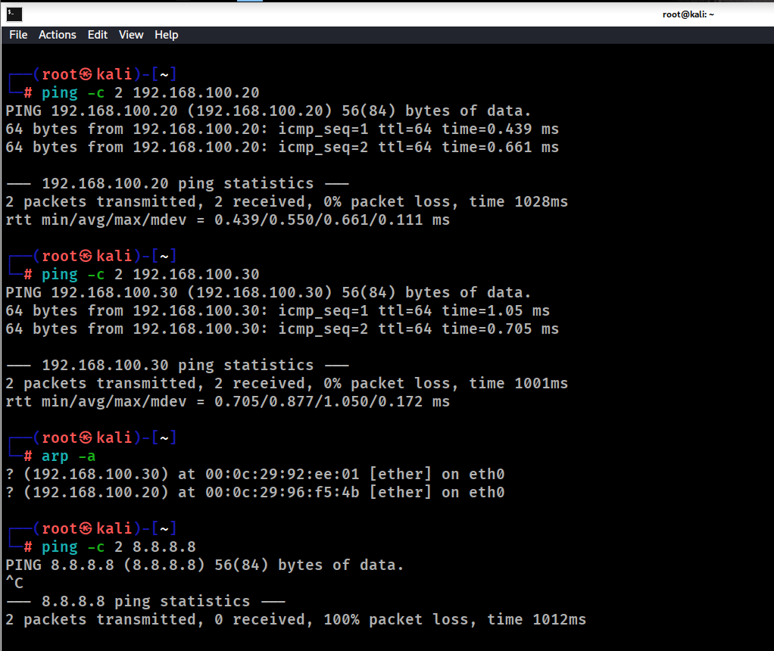
Figure 2. Domain Validation Tests

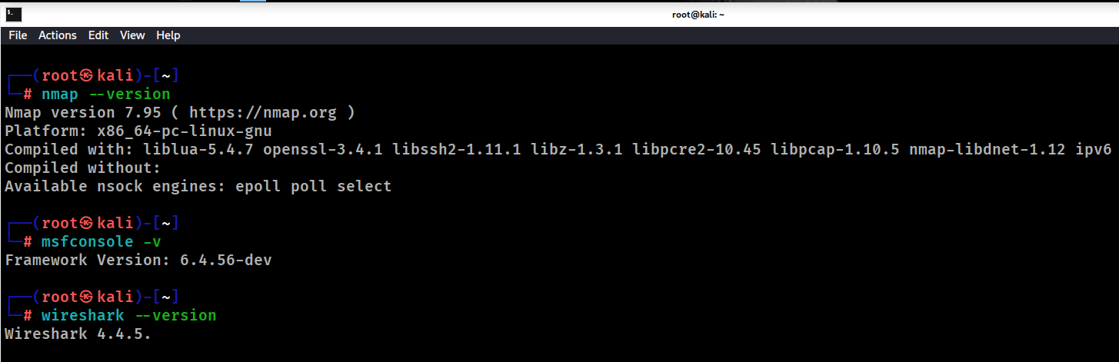
Figure 3. Tool Availability Tests

4.2 Test Scenario 2: Snapshot and Recovery Test

Objective: To ensure the lab can be reset to a clean state using VMware snapshots, allowing repeatable exercise
Procedure:

- The first step was to create a snapshot in a “clean” state. In this scenario it was the Kali machine just having 2 user at hand, namely “kali” and “mrchikomba”.
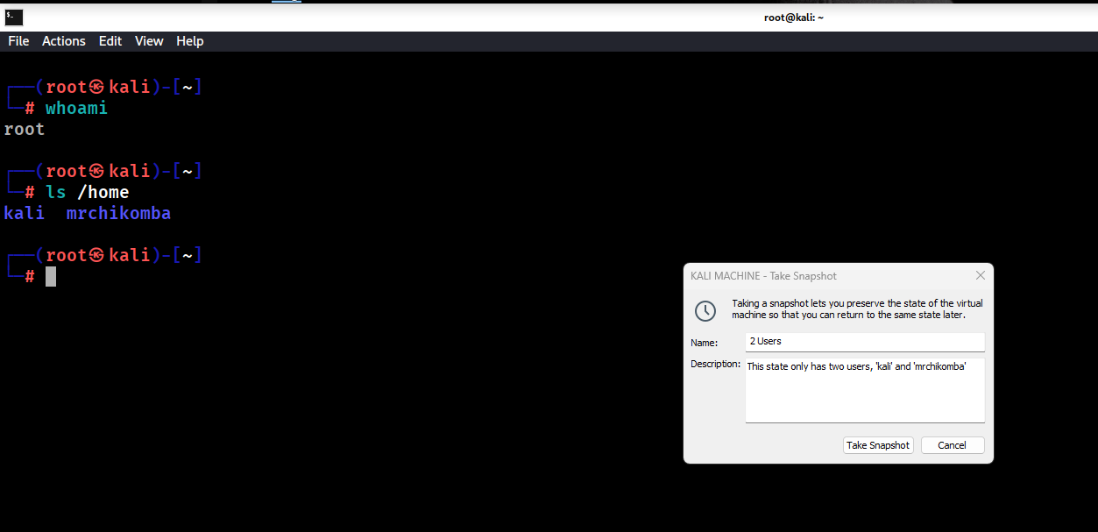
Figure 4. Clean Snapshot State

- The second step was to perform a simple change to the system, which was as show in the figure below, adding a user “testuser” to the system. This user would now be visible in the current state directory after running the “ls /home” command.
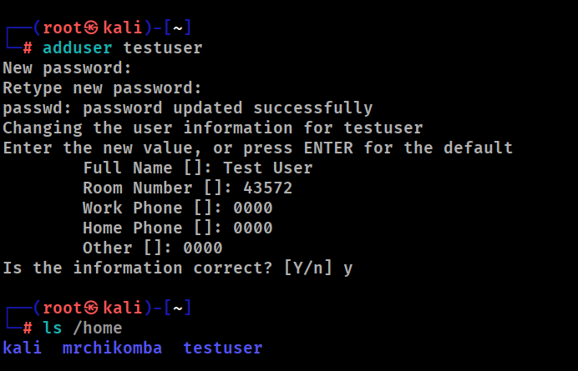
Figure 5. Adding new user

- The next step was to shut down the system, access the snapshot manager and revert to the snapshot that was created earlier (“2 Users”)

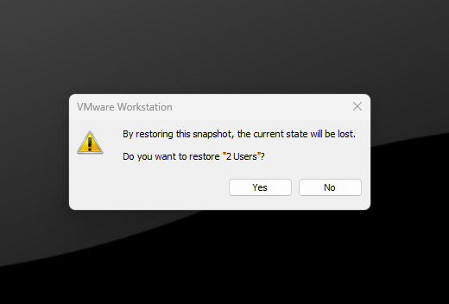
Figure 6. Snapshot Manager Prompt

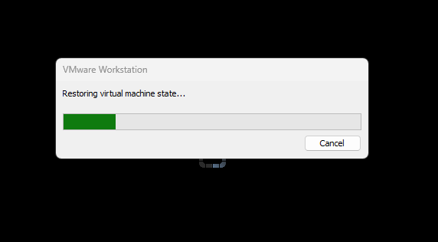
Figure 7. Restoring Virtual Machine State

- After restoring the snapshot, the last step would be to check the users in the system, and as shown in the figure below, there are only the two original ones, not including the “test user”. This then validates the snapshot functionality of the lab, showing we can restore our machine states from where we snapshot them

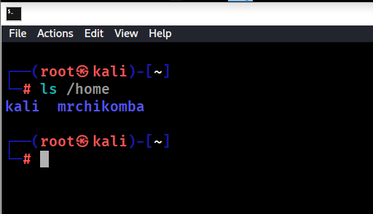
Figure 8. Recovered Snapshot State

The validation tests successfully confirmed the core operational and pedagogical requirements of the virtual lab. The Ping and ARP tests verified that the VMware Host-Only network provided correct Layer 3 connectivity and Layer 2 address resolution between all virtual machines while maintaining complete external isolation. Furthermore, the Snapshot Test demonstrated the crucial ability to reliably revert any virtual machine to a pristine, predefined state, ensuring a consistent and repeatable starting point for all exercises, which is fundamental for safe, experimental learning and fair assessment. The test scenarios for the lab, their expected results and the eventual outcome are all summarized in the table below.

5. Hands-On Lab Exercises
This chapter presents two guided, hands-on exercises designed to reinforce key offensive and defensive cybersecurity skills within the controlled virtual lab environment. Each exercise simulates a realistic scenario—first from the perspective of an attacker exploiting a vulnerability, and second from the viewpoint of a defender detecting and mitigating an attack. By following these step-by-step procedures, students will gain practical experience in vulnerability assessment, exploitation, monitoring, and response, integrating tools such as Nmap, Metasploit, Wireshark, and iptables into a coherent workflow.

5.1 Exercise 1: DDoS Attack & Mitigation
Objective: Simulate a SYN flood attack and implement defensive countermeasures.

5.1.1. Phase 1: Reconnaissance and Scanning

Use nmap from Kali to identify the Ubuntu server’s IP and open ports. This is done by using the “nmap –sS [Target IP]” command

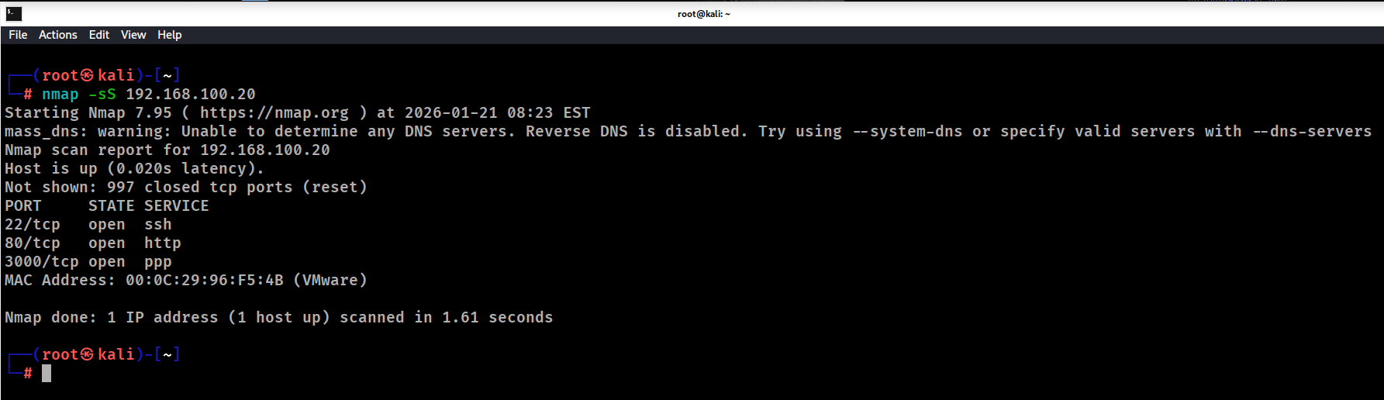
Figure 9. Reconnaissance and Scanning

5.1.2. Phase 2: Attack
Launch a ICMP flood against Ubuntu using hping3. The command used is “hping3 -1 –flood –p 80 [target ip]

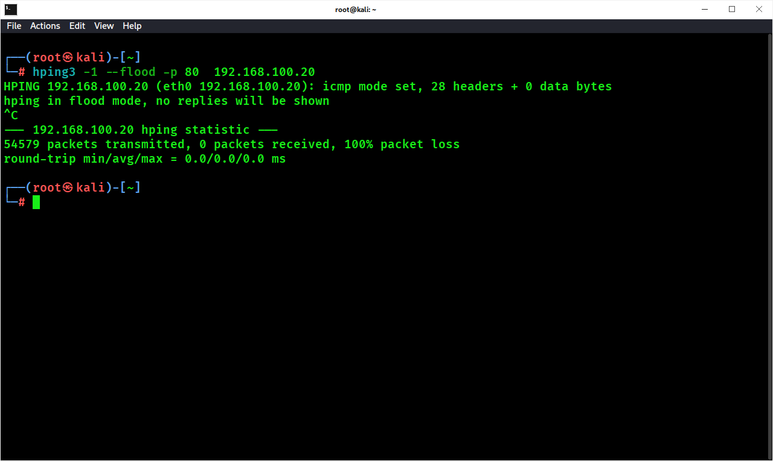
Figure 10. Hping3 Attack

5.1.3. Phase 3: Detection
On Ubuntu, use Wireshark to monitor traffic spikes. This can be achieved by accessing the Wireshark and picking an interface to listen on (i.e eth0). After selecting an interface you can start the packet capturing and observe the traffic behavior between the Kali machine which launched the hping3 attack and the Ubuntu machine. The pings are flagged as “ICMP” under the protocol tab, and will be moving in large volumes.

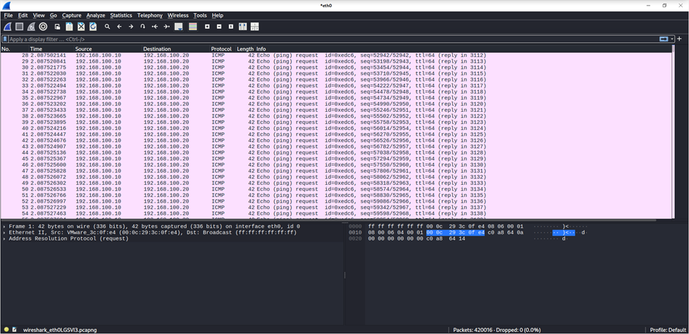
Figure 11. Wireshark Capture of traffic spikes

5.1.4. Mitigation

Configure iptables rules to limit SYN packets per minute and block the attacker’s IP. The command used to apply this is “sudo iptable –A INPUT –p tcp –dport 80 –m limit –limit 25/minute –j ACCEPT”. This tells Ubuntu to allow incoming TCP traffic to port 80, but only up to 25 packets per minute. Anything beyond that will not be accepted (assuming a default DROP or REJECT policy).”

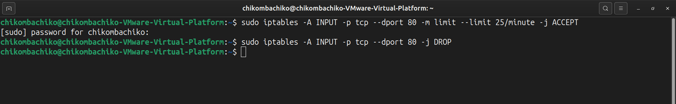
Figure 12. Iptables rate limiting

5.2 Exercise 2: Vulnerability Scanning, Exploitation & Patching
Objective: Identify a vulnerability, exploit it, and apply a patch.

5.2.1. Scanning
Use “nmap –sV [target IP]” from Kali to scan Metasploitable for services and versions. This should enumerate the open ports, services and versions on the target IP

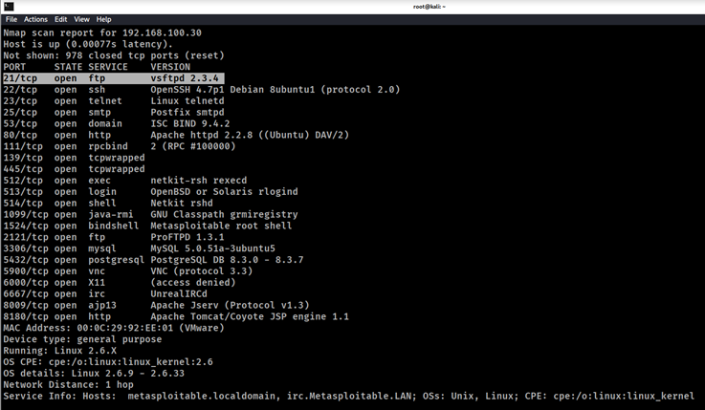
Figure 13. Nmap scan on Metasploitable

5.2.2. Identification
Locate vsftpd 2.3.4 with a known backdoor (CVE-2011-2523). This can be done by using the msfconsole and searching the auxiliary for the specific vulnerability in question.

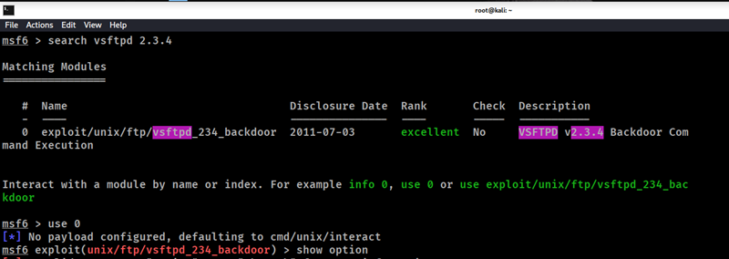
Figure 14. Identifying vsftpd backdoor

5.2.3. Exploitation
Use Metasploit to exploit vsftpd and gain a reverse shell.

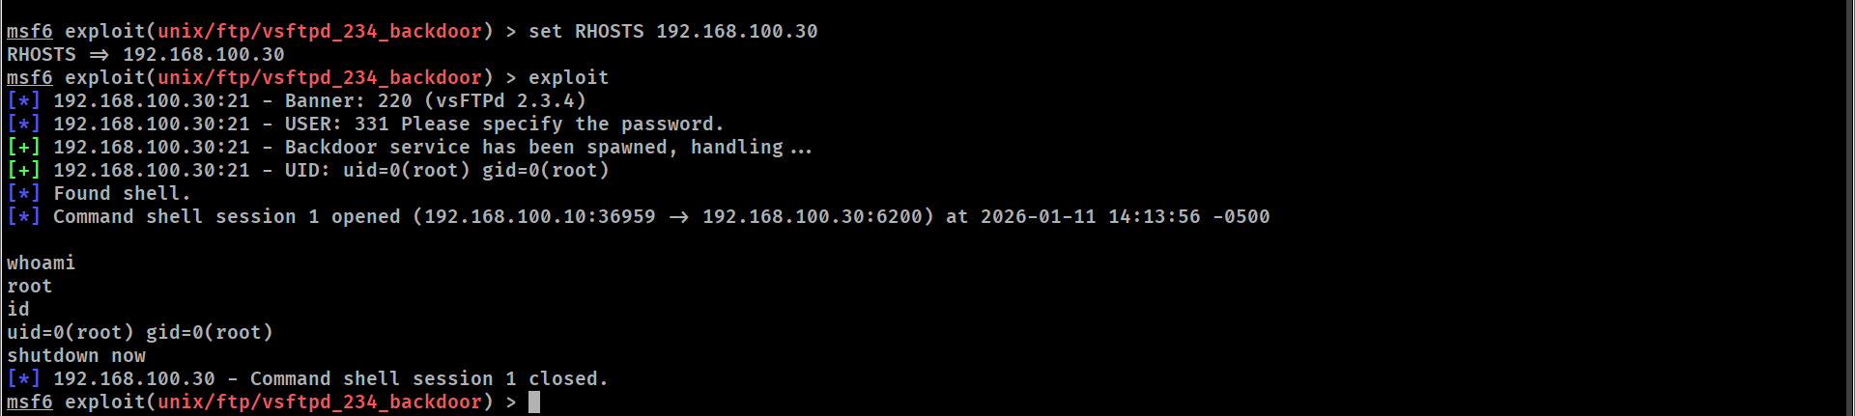
Figure 15. Exploiting vsftpd

5.2.4. Patching
On Metasploitable, update vsftpd to a secure version via “apt”. This stage can present several limitations due to Metasploitable being a heavily misconfigured system, and the lack of internet access. However for this stage, you will need to change Metasploitable’s network adapter to NAT, inorder to update the vsftpd. Even so, due to Metasploitable’s limitations you will be restricted to downloading an earlier version of the vsftpd, namely “vsftpd 2.0.6” for this lab.

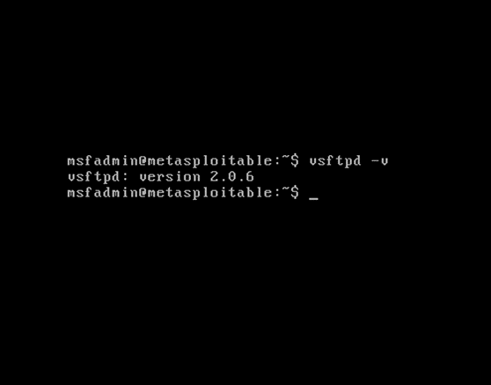
Figure 16. Vsftpd patching

5.2.5. Hardening
After updating the vsftpd version, you can proceed to harden the system by setting up the service configuration file.

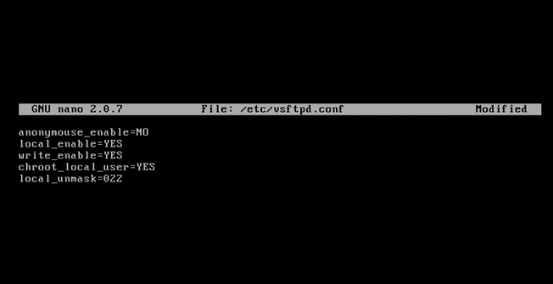
Figure 17. Hardening vsftpd configuratio
5.2.6. Rescan
Confirm the vulnerability is closed with a follow-up nmap scan. The expected result is the vsftpd version to be up to date (2.0.6), away from the vulnerable 2.3.4 version

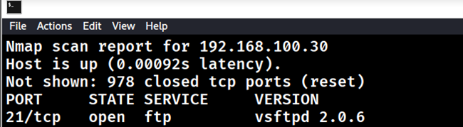
Figure 18. Rescan on vsftpd

The next step would be to check if there are any modules within the Metasploit auxiliary that can exploit the updated version. For this step you can use the “searchsploit” command on the vulnerability in question

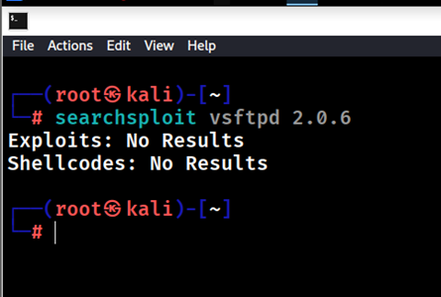
Figure 19. Searchsploit on updated vsftpd

Lastly, to confirm that the vulnerability has been mitigated, we try the vsftpd 2.3.4 backdoor module on the updated version, which should not be successful.

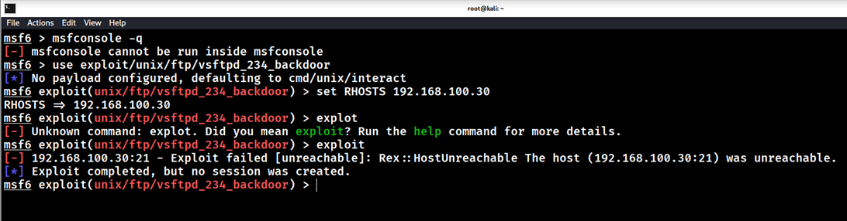
Figure 20. Backdoor attempt on new

5.3 Exercise 3: Man In The Middle Attack
Objective: Intercept traffic between two users ( Metasploitable & Ubuntu)

5.3.1 Enable IP Forwarding
On Kali Enable IP forwarding to route traffic from Metasploitable and Ubuntu

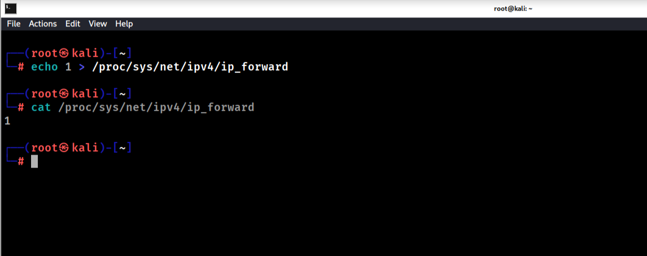
Figure 21. IP Forwarding on Kali

5.3.2 Initialize Arp Poisioning
On Kali, initialize an arp poisoning attack. This is done by telling Metasploitable that you (Kali- the attacker) are Ubuntu, and vice-versa telling Ubuntu that you are Metasploitable

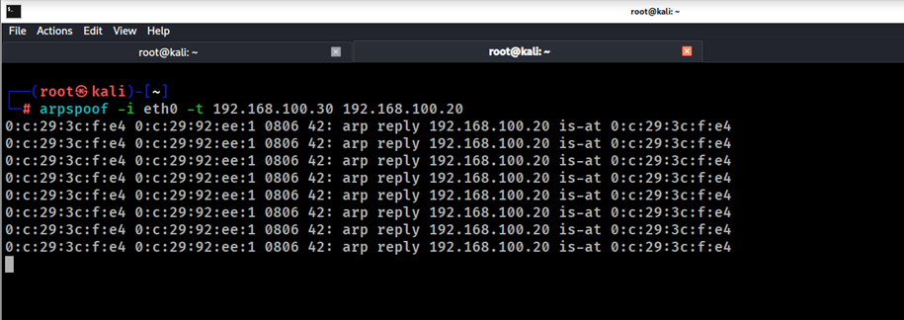
Figure 22. Arp Poisoning on Metasploitable

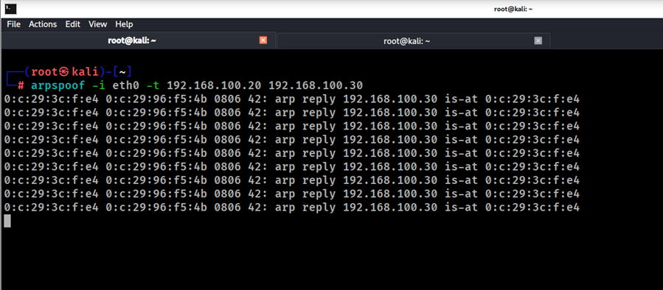
Figure 23. Arp Poisoning On Ubuntu

5.3.3 Generate traffic on Metasplotable to Ubuntu
On Metasploitable, generate traffic to Ubuntu. This can be in the form of pings or a simple telnet.
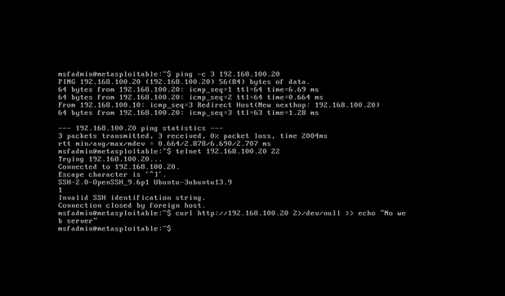
Figure 24. traffic generated between Metasploitable and Ubuntu

5.3.4 Packet Listening and Capturing
Use tcpdump to listen and capture packets between Metasploitable and Ubuntu

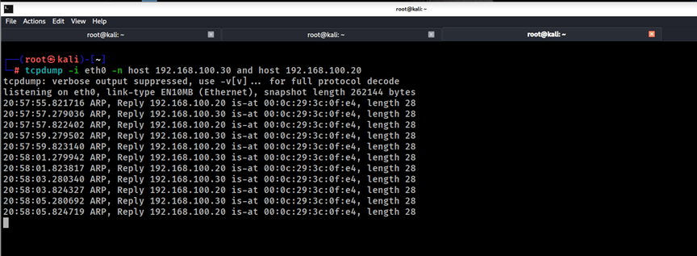
Figure 25. tcpdump packet capture

5.3.5 Analyze the packets in real time
As the packets are captured in real time, analyze them. And see what traffic can be captured during a man in the middle attack

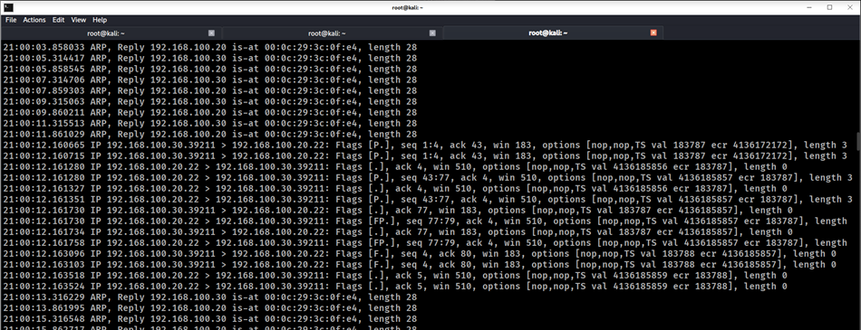
Figure 26. Captured traffic

Learning Outcomes
Upon completing these exercises, students will develop foundational offensive security skills, beginning with the ability to conduct structured reconnaissance and vulnerability scanning. This involves moving beyond theoretical concepts to practically employ tools like Nmap using methodical scanning techniques (-sS, -sV) to map network topology, enumerate live hosts, identify open ports, and fingerprint services. Following discovery, they learn to utilize the Metasploit Framework to ethically exploit known vulnerabilities, such as the vsftpd backdoor. This process grounds abstract Common Vulnerabilities and Exposures (CVE) entries in reality, as students navigate the msfconsole, configure exploit modules, set payloads, and execute attacks to gain a reverse shell, thereby understanding the complete chain from vulnerability identification to successful compromise.

Concurrently, students cultivate essential defensive and analytical capabilities. They learn to monitor network traffic and system logs for signs of intrusion, using Wireshark to capture and analyze packet flows—distinguishing normal patterns from malicious traffic like SYN floods. This observational skill is directly applied to implement defensive configurations, such as crafting and deploying precise iptables firewall rules to rate-limit or block attack traffic in real-time. Finally, the exercises instill professional rigor by requiring students to produce clear incident documentation for analysis and review. This synthesizes their technical actions into a coherent narrative, logging attack vectors, observed indicators of compromise, mitigation steps taken, and post-patch verification results, mirroring the reporting standards required in real-world security operations center

6. Practical Use Cases
This chapter presents practical scenarios demonstrating the applied value of the Virtual Cybersecurity Lab beyond structured training exercises. These use cases illustrate how the lab serves as a versatile platform for education, skill assessment, and safe environment testing in real-world contexts.

6.1. Use Case 1: Deployment and Account Creation
The practical deployment journey begins with the acquisition of the pre-configured Virtual Cybersecurity Lab package, containing the virtual machine images for Kali Linux, Ubuntu Server, and the intentionally vulnerable Metasploitable2 target. The user imports these images into their local virtualization platform (e.g., VMware Workstation), powers on each machine, and completes the initial boot sequence. Metasploitable2 is immediately operational with its preconfigured, well-documented credentials, requiring no initial user setup and serving as an instantly accessible target for security exercises.

Initial access configuration is then performed on the primary operational systems. On the Kali Linux machine, the user confirms or establishes a user account via the initial system prompts, securing command-line and graphical interface access to the comprehensive penetration testing toolkit. Similarly, on the Ubuntu Server system, the user completes the post-boot setup, creating a dedicated administrative account that will serve as the foundation for all subsequent defensive monitoring, logging, and firewall configuration activities. This streamlined process delivers a fully functional, multi-role lab environment in minutes, with clear ownership and access established for the attacking (Kali) and defending (Ubuntu) platforms
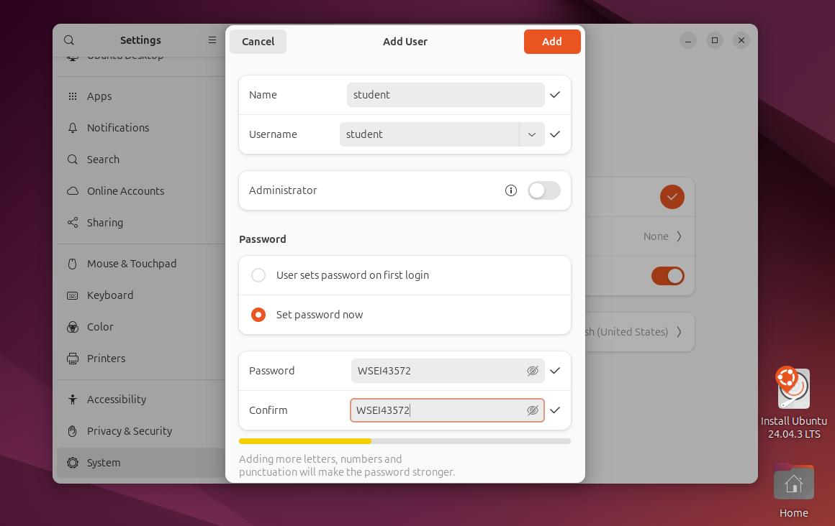
Figure 27. Account Creation

6.2. Use Case 2: Network Isolation Configuration
The critical network isolation process begins within the virtualization platform's network management interface, where the user creates a new Host-Only virtual network adapter (typically designated as VMnet9 in VMware and labeled 'LabNet'). This adapter is configured with a defined private IP subnet (192.168.100.0/24) and crucially has all external connectivity features—such as NAT service and bridged connection to physical hardware—permanently disabled. This configuration creates a software-defined network switch that exists solely within the host machine's memory, establishing the foundational boundary that contains all subsequent lab activity

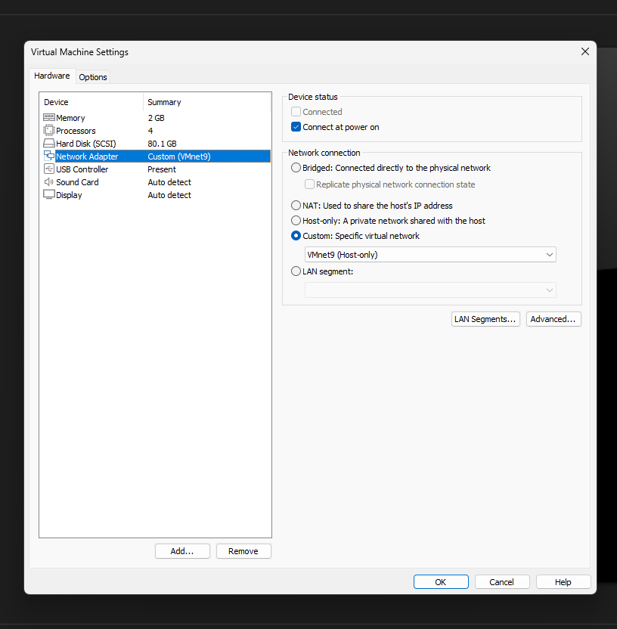
Figure 28. Network Isolation

6.3. Use Case 3: Maintenance and Tool Updates
This use case tackles the ongoing maintenance challenge of keeping the lab relevant while preserving its core training vulnerabilities. The process is initiated by temporarily reconfiguring the network adapter of a specific machine—typically the Kali Linux attacker or Ubuntu defender VM—from the Host-Only 'LabNet' to a NAT or Bridged network, granting it temporary, controlled internet access. The user then performs targeted updates; on Kali, this involves running sudo apt update && sudo apt upgrade to refresh the penetration testing toolkit to its latest stable versions, ensuring exposure to current tool capabilities and security patches.

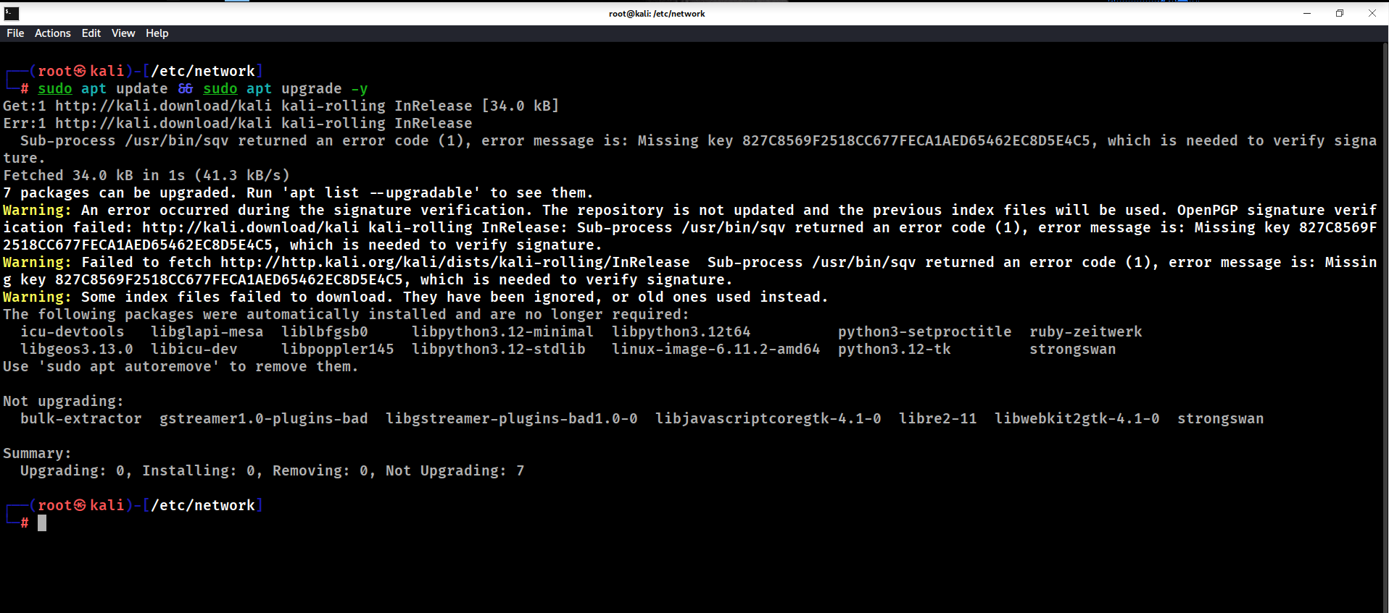
Figure 29. System update on Kali

Conversely, the Metasploitable2 target system is deliberately excluded from this update process. Its network remains strictly isolated, or its update sources are intentionally disabled, to preserve the carefully curated, outdated services and known vulnerabilities (like vsftpd 2.3.4) that are essential for exploitation exercises. After updates are complete, the updated machine's network adapter is reconfigured back to the Host-Only 'LabNet,' re-establishing total isolation. The user then validates internal connectivity and runs a verification command (e.g., nmap --version on Kali) to confirm tool updates, followed by a test exploit against Metasploitable to ensure the core training vulnerabilities remain intact and functional.

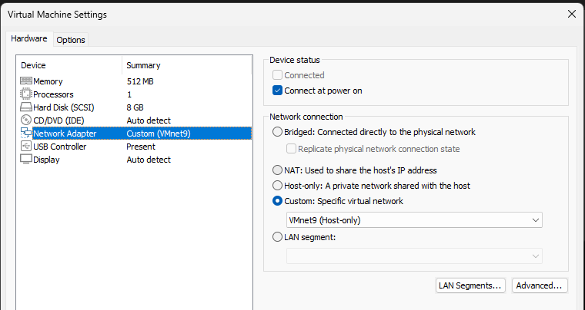
Figure 30. Reverting Back to Host Only

7. SUMMARY
This thesis project successfully designed, implemented, and validated a functional Virtual Cybersecurity Lab, addressing the critical theory-practice gap in cybersecurity education. The core achievement lies in creating a fully isolated, reproducible environment using desktop virtualization, which provides a safe and legal platform for hands-on experimentation with real-world attack and defense scenarios.

The implemented lab architecture, based on a Host-Only VMware Workstation network, integrates three specialized virtual machines: Kali Linux for offensive security operations, Metasploitable2 as a deliberately vulnerable target, and Ubuntu Server for defensive monitoring. This design aligns with the pedagogical requirements for hands-on learning outlined by educational frameworks such as Tomei’s Taxonomy[12], facilitating higher-order cognitive skills like analysis, decision-making, and integration (Tomei, 2001; Son et al., 2012).

Key technical challenges, including network isolation, performance optimization, and tool compatibility, were systematically resolved. Network isolation was ensured through VMware’s Host-Only networking configuration, containing all lab activities ethically within the virtual environment. Performance was managed through careful allocation of host resources, and exercise reproducibility was achieved via snapshot management.

The lab’s educational value was demonstrated through four validated test scenarios—Lab Boot/Network, Vulnerability Scanning, DDoS Attack/Mitigation, and MITM Attack/Detection—and a comprehensive use-case exercise. These exercises provide structured pathways for students to develop practical skills in reconnaissance, exploitation, monitoring, and incident response using industry-standard tools like Nmap, Metasploit, and Wireshark.
While this project implements a cost-effective, single-user desktop virtualization model (aligning with approach A4 identified by Son et al., 2012), it establishes a foundation for future expansion. Potential enhancements include scaling to a cloud-based deployment using open-source platforms like KVM and OpenStack for remote multi-user access, integrating automated assessment systems, and developing AI-powered adaptive learning scenarios. This project confirms that virtual labs are a vital and effective component in developing the competent cybersecurity professionals needed in today’s evolving threat landscape.

7 Bibliography

- Bejtlich, R. (2019). The Practice of Network Security Monitoring. No Starch Press.
- Cole, E. (2020). Hacking: The Art of Exploitation (2nd ed.). No Starch Press.
- Gardner, H. (1993). Frames of Mind: The Theory of Multiple Intelligences (10th Anniversary ed.). Basic Books.
- Kali Linux Documentation. (n.d.). Penetration Testing Tools Guide. Retrieved from https://www.kali.org/docs/
- Metasploit Unleashed. (n.d.). Free Ethical Hacking Course. Offensive Security. Retrieved from https://www.offensive-security.com/metasploit-unleashed/
- Mitnick, K. (2018). The Art of Deception: Controlling the Human Element of Security. Wiley.
- NIST. (2019). NIST Guide to Intrusion Detection and Prevention Systems (IDPS) (Special Publication 800-94 Rev. 1). Scarfone, K., & Mell, P.
- OWASP Foundation. (2023). OWASP Top 10:2021. Retrieved from https://owasp.org/www-project-top-ten/
- Sikorski, M., & Honig, A. (2022). Practical Malware Analysis: The Hands-On Guide to Dissecting Malicious Software (2nd ed.). No Starch Press.
- Son, J., Irrechukwu, C., & Fitzgibbons, P. (2012). Virtual Lab for Online Cyber Security Education. Communications of the IIMA, 12(4), Article 5.
- Stallings, W. (2021). Cybersecurity Essentials. Pearson.
- Tomei, L. A. (2001). Teaching Digitally: A Guide for Integrating Technology into the Classroom Curriculum. Christopher-Gordon Publishers.
- VMware. (2023). VMware Workstation Pro User Guide.

LIST OF FIGURES
Figure 1. System Design Architecture 31
Figure 2. Domain Validation Tests 42
Figure 3. Tool Availability Tests 42
Figure 4. Clean Snapshot State 43
Figure 5. Adding new user 44
Figure 6. Snapshot Manager Prompt 44
Figure 7. Restoring Virtual Machine State 45
Figure 8. Recovered Snapshot State 45
Figure 9. Reconnaissance and Scanning 47
Figure 10. Hping3 Attack 48
Figure 11. Wireshark Capture of traffic spikes 49
Figure 12. Iptables rate limiting 49
Figure 13. Nmap scan on Metasploitable 50
Figure 14. Identifying vsftpd backdoor 51
Figure 15. Exploiting vsftpd 51
Figure 16. Vsftpd patching 52
Figure 17. Hardening vsftpd configuratio 52
Figure 18. Rescan on vsftpd 53
Figure 19. Searchsploit on updated vsftpd 53
Figure 20. Backdoor attempt on new 54
Figure 21. Account Creation 56
Figure 22. Network Isolation 57
Figure 23. System update on Kali 58
Figure 24. Reverting Back to Host Only 58

LIST OF TABLES
Table 1. Functional Requirements of the Virtual Cybersecurity Lab 22
Table 2. Tools and Technologies Used in the Virtual Cybersecurity Lab 26
Table 3.Virtual Machine Configuration and Roles 29
Table 4. IP Addressing for the Lab 37

